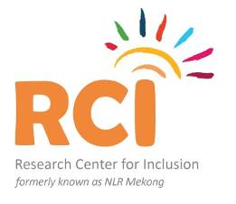
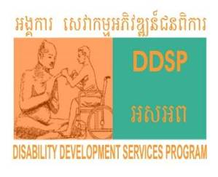
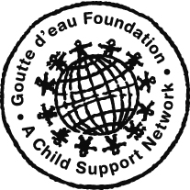
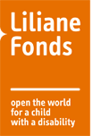
End Year

Project Annual Narrative Report
January to December 2019

Name of the Partner Organization: | Disability Development Services Program (DDSP)
Project Title | Mith Komar Pikar Project (Friend of disabled children)
Project period | January to December 2019
Project site | Pursat province, Cambodia
Donors/sponsors | Goutte déau/a child support network, LF/RCI and REECH Cambodia

- Beneficiary
Children and Youth with disabilities | Total | Female
Mlob Mith Komar (MMK) | 55 | 28
Integrated classes for children with ID | 46 | 19
Daycare Talo | 18 | 3
Inclusive education | 77 | 34
Parents and/or caregivers | 372 | 196
Relevant stakeholders involved in the program  (Teachers, health workers, government official) | 210 | 95

B. BACKGROUND INFORMATION

- Local context analysis

The Mith Komar Pikar ‘’Friend of Disabled Children” project is one of DDSP’s project of five projects, (1) Mith Komar Pikar project (MKP), (2) Community Base Rehabilitation Project (CBR), (3) Paraplegia and Quadriplegia rehabilitation (PQR) and (4) Water and Sanitation (WATSAN); the WATSAN Project is the cross-cutting project and (5) Communication and advocacy for change project.
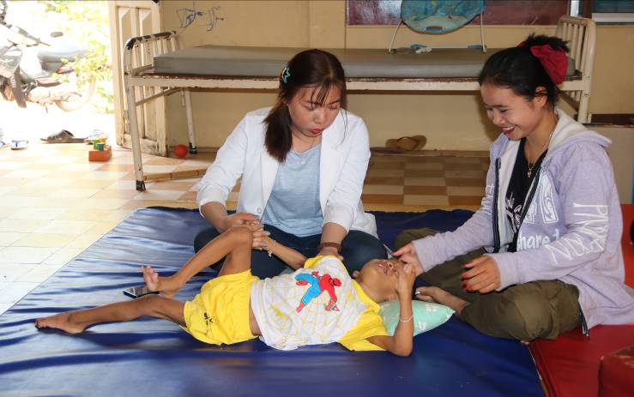
The Mith Komar Pikar project is aiming to meet the educational and rehabilitation needs of children with disability (CWDs) and the socio-economic needs of their families. The project has four components aimed at different groups of disabled children; (a) Inclusive education class intervenes to help CWDs to access education in public schools which focus on children with mild disability, such as difficulty in hearing, speaking, seeing and/or vulnerable children who affected by poverty, (b) Integrated classes for children with special needs who are with intellectual disabilities such as autism, cerebral palsy, downsyndrome….., (c) The Mlop Mith Komar Centre (MMK), in collaboration with Pursat hospital, supports therapy services for children with severe cerebral palsy, (d) Daycare Talou centre was operated services through integration approach which children and young adult with disability can learn on speech and communication language, basic education, daily activities and received physic-therapy services and nutrition food for improving their health status. The non-disability children of primary school can also access the small library to improve their general knowledge from the Daycare.

Presently, the Royal Government of Cambodia is working hard to promote the welfare of persons with disabilities by promoting/implementing the relevant national laws/policies, five-year national strategic plan on disability (2019-2023); strategy of the development goals (SDGs); and the Law on the Protection and Promotion of the Rights of Persons with Disabilities.
- Problem analysis and relevance: The following challenges are faced by CWDs:
- Some CWDs were kept at home and lack of rehabilitation; they could not attend school and/or rehabilitation center;
- The negative attitudes of the people in community toward CWDs;
- Lack of transportation/bicycles for CWDs who live far from school;
- Teachers at state school lack of skill in teaching CWDs and also lack of motivation; this leads CWDs could not retain at school;
- Parents of CWDs do not value education for their children and not well taking care them as other children; so they do not send them to go to school;
- Lack of accessibility at school such as no ramp to access the classes and toilets/bathrooms; especially for wheel-chair users.
- Migration of CWDs’families due to the poverty; most of CWDs come from poor families who are less likely to send their children to school as the child labor is needed to earn income and so on.
C. PROGRAM/PROJECT DESCREIPTION
a. The inclusive education: The project covers 16 primary schools from 3 clusters of state schools which mainly focuses on improving school accessibility, quality of teaching and learning of vulnerable children; especially, CWDs. The main activities of the project are building school ramps, encourage school to build adapted latrine, refer CWDs access rehab/health services, provide learning materials and transportation for CWDs to go to school, train school teachers on Inclusive Education and conduct awareness-raising to increase the number of children with disabilities at school and etc. Currently; there are 77 (with 34 female) CWDs benefit from the project.
As a result; children with disabilities come to school regularly; and the teachers were trained on inclusive education; they have greater understanding and knowledge on how to teach children with disabilities and manage their classes.

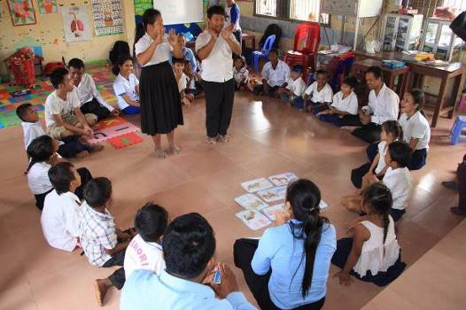
b. The integrated classes for children with intellectual disability: DDSP and local School Directors run two integrated classes; at Phrey Nhi and Boeng Khna primary school, for children with intellectual disabilities; that’s only two classes in Pursat and non NGOs can do such important education for them in the province. The classes run five days per week with the main activities focus on special education, self-care education on health and hygiene life skills activities, arts and sports. 46 children with 19 female benefits from the classes.

Through Individual Development Plan evaluation for each child; we found that many of them can read, count number, do math, and write. Moreover; all children/youth with disabilities have improved their daily activities include eating, bathing, wearing clothes, brushing, toileting ...etc by themselves. Their physical and cognitive impaired is also rehabbed.

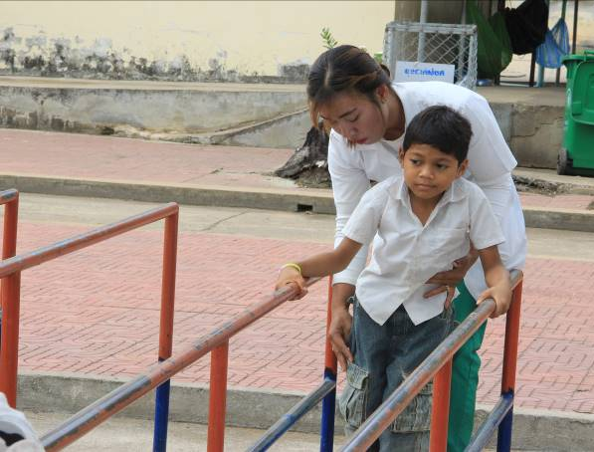
c. Mlop Mith Komar (MMK)/Physio-therapy Centre: Mlob Mith Komar is the rehabilitation centre located in Pursat hospital, it severed children with severe disabilities (Cerebral Palsy, Epilepsies, Down-Syndrome, cognitive impairment….). Most of them have difficulties in sitting, standing, and walking and also cannot eating, drinking, dressing, toileting independently. We work three days a week, Monday, Wednesday and Friday, in the morning session we do physical therapy for those children in the center and in the afternoon we do home visit for home-based therapy, teach family members on basic therapy so that they can treat their children at home and do counseling.

In the meantime; there are 55 children with 28 female benefit from the project. During this reporting period we found that all children have much improvement on their function, communication and health situation.

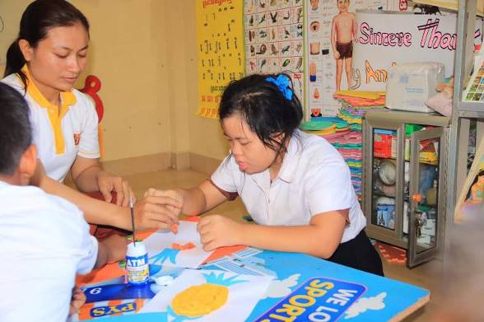
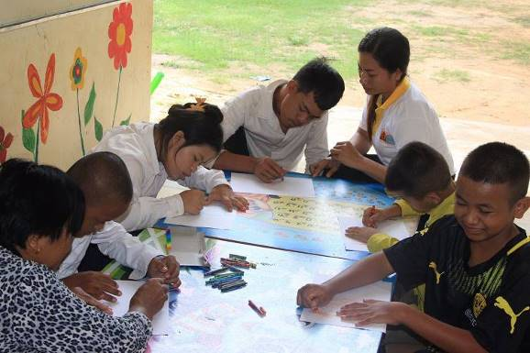
d. Day care Talou Center: The Center is located at Talou primary school, Talou, commune Bakan district is rehabilitation centre for children with severe disabilities and most of them have similar situation of disabilities Cerebral Palsy, Epilepsies, cognitive impairment... and so on. They have difficulties with sitting, standing, and walking and also cannot eating, drinking, dressing, toileting independently. Currently; There are 18 children/youth with disabilities (3female) benefit from the project. They are so delighted with the project support. The Center runs four days a week Monday, Tuesday, Thursday and Friday which starts from 8pm to 4pm; the activities are similar to activities at MMK above. However; A part of the center is also used as an integrated class for children and youth with disabilities. Daily life activities and food (breakfast, lunch and snack) is also provided at the center.

Here are the other main project results during this reporting period.
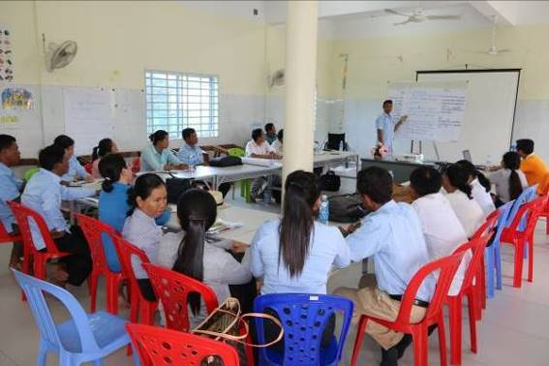
- Teacher Capacity Building on Inclusive education: With financial support from Liliane Foundation and technical support from the provincial department of Education, Youth and Sport; we have conducted a one day-training, on Inclusive Education; on 14 June 2019, to 25 teachers including 12 females from different target schools. The purpose of the training is to building the capacity of teachers and improve the quality of teaching for children with disabilities. The training topics includes disability awareness, disability identification, disability inclusion, class management and the technique on how to facilitate the children with disabilities. Slide show, group discussion and brain storming were used to facilitate the training. Due to the limitation of the budget; we are sad to run just a one-day training. However; teachers shown very great understanding on the topics and commit to apply what they have learned to improve their teaching quality for those vulnerable children.

- Public event:

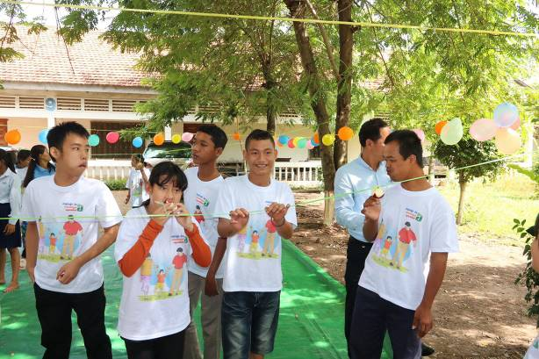
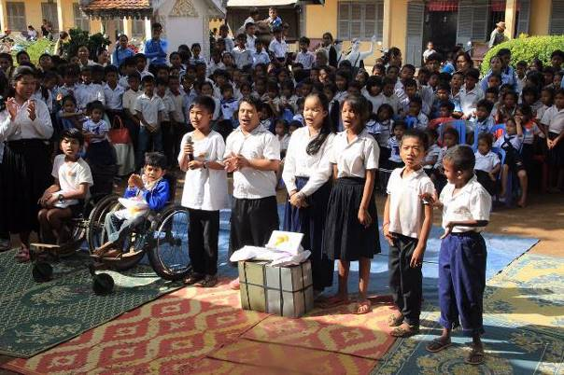
- Public event: The International Children’s Day: On 1st of June DDSP supported 9 schools in our target area to conduct the 70th Children’s Right Day. In this crucial event there were more than 1,000 participants from mix back ground; these include 162 school teachers, 145 children with disabilities, and the rest are parents of children, local authority, the representatives from the district and provincial of education. The goal of this special event is to promote the right of children especially the children with disability’s right to access education and other 4 rights of the children; i.e rights to live, rights to protect, and rights to development and decision making. Learning materials such as writing books, pens, pencils, and cake were contributed during the events. To promote the participation of both children with/without disability; questions related to children’s rights and disability, speeches and games were developed for them to enjoy. They had a great participation.

Through the event we observe that the people in community and local authorities have a great understanding about children with disability’s right and disability inclusion; the important of social inclusion, disability law. And they have shown high commitment in pushing their children to go to school and reduce discriminated behavior towards children and persons with disabilities.

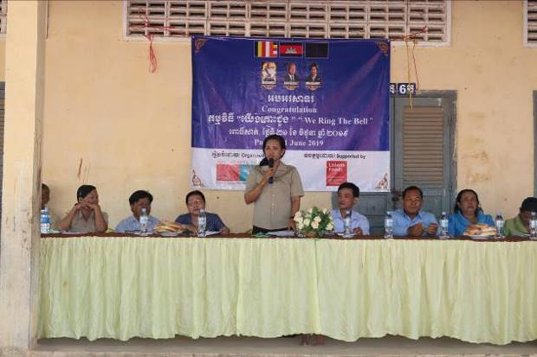
- “We Ring The Bell”: With the collaboration from the local authorities and school director; the event was organized on 21st June 2019. The event aimed to promote the Child’s Rights and the important of education for all children especially children with disabilities; it is also to encourage parents, local authorities and communities to send their children to access education. The event was celebrated in the compound of Phrey Nhi primary school, one of our target schools, in the city of Pursat, Pursat province. There were 642 participants invited to participate this important event, they’re from Government officials, Department of Social Affair Veterans Rehabilitation, Department of Women Affaire, local authorities, teachers/principle, School support committee, school teachers, Students, children with disabilities, parents, NGOs partners, and people in community.

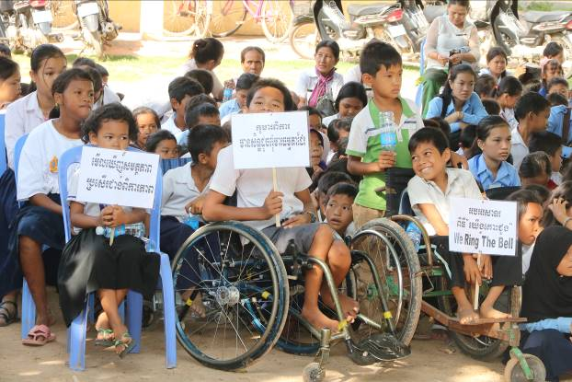
The gifts, i.e: learning materials; were to children with disabilities and others vulnerable children; snack, fresh water were provided to the participants, music and TV broad cast also high light in the event. It was reported that the participants have a great understanding on the purpose of the event and the important of the education for their children, especially children with disabilities. Disability issue awareness-raising was resulted in the decreased discriminatory as well as they tended to be more open-minded to integrate children and people with disabilities in community and other social activities. The Chair of district governor, Officers from PoSVY, PoEYS, PoWA and local authorities also expressed their grateful and remarks to this important event. At the same time; they expressed their sincere thanks to DDSP and LF to make this event happened and wishing the best of luck and all success.

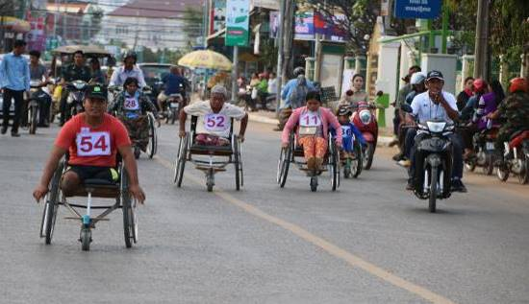
- Disable Persons’s Day and Sport Event: On 16th December 2019, DDSP collaborated with department of Social Affair Veterans and Youth Rehabilitation (PoSVY) celebrated the 21st Cambodian Day of Person with Disability and the 37th International Day of Persons with Disability Day on “Together remove the barriers for person with disabilities for an inclusive society”_ it was held at the provincial office PoSVY. The event aimed to promote the participation of persons with disability and to aware the communities and stakeholders on the rights of persons with disability and to enforce the Law on the Protection and Promotion on the Rights of Persons with Disability. At this special event, Director of PoSVY, Mr. Eang Hong, honored and very delighted to give speech.

There were 215 participants invited to participate the event; they are persons with disabilities, Government officials, local teachers/principle, local authorities, Students, NGOs partners, and community members from DDSP target villages.

At the same time; sport racing and running were organized for wheelchair-users, amputee and children/youth with intellectual disabilities in order to promote sports for persons with disabilities. They were very enjoying with the event and racing. Gift, snack, drinking-water and transportation cost was provided to persons with disabilities who participated the event.
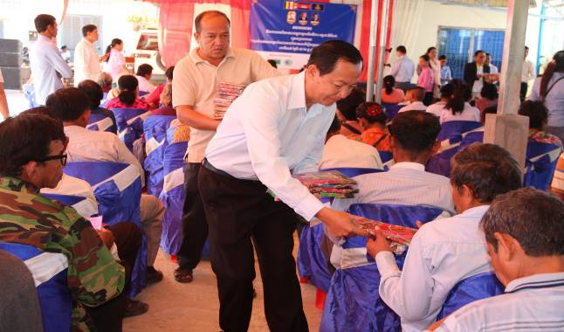
As the result; the participants were very impressed and delighted to be part of the event as they gained more knowledge and understanding on disability issue and other legislation related to disability which raised by the guest speakers. Honorable guests, local authorities and all participants shown their gratefulness and interest to the event. Director of PoSVY expressed his remarks with very deep thanks to DDSP and donors to support this event and he requested to support further events.

Report activities and results implemented/achieved following the plan

Goal: Improve the quality of lives of children with disabilities through the Community-Based Rehabilitation activities.
Outcome 1: More children with disabilities accessed to quality education with their non-disabled peers at the mainstream school
Output: 1.1: At least 50 children with disabilities at the inclusive classes assessed and supported to schools;
Activity No | Activity Title | Time | Description of the activity carried out | Specific & measurable indicators of the achievements
1.1.1 | Working with local authority to conduct school mapping | 6 times | It is done.  School mapping was conducted with the local authorities and teachers. | 12 schools
1.1.2 | Conducting assessment and children/parents counseling. | 50 times | It is done.  All the target CWDs have been assessed for support. | 50 CWDs from the poor families
1.1.3 | Support children needed to go to school. | 50 times | This activity has been done. | CWDs assessed and supported to go to school.
Output: 1.2 Learning materials and special need teaching provided
Activity No | Activity Title | Time | Description of the activity carried out | Specific & measurable indicators of the achievements
1.2.1 | Working with the team and relevant teachers to identify the needed children for providing learning materials | One time each child | Done.  50 CWDs have been assessed for providing learning materials for their schooling | 50 CWDs identified to receive learning materials
1.2.2 | Purchasing and providing learning materials | 1 time | Done.  50 kits of learning materials were purchased and provided to identified CWDs as plan. | 50 CWDs received kits of learning materials
Output:1.3: school attendance increased and new disabled children found;

Activity No | Activity Title | Time | Description of the activity carried out | Specific & measurable indicators of the achievements
1.3.1 | Conduct school mapping | 6 times | It is done. (see 1.1.1) | It is estimated that at 90% of children access school with better care from the teachers and their parents.
1.3.2 | Coordinate with teacher in helping children | X | It is done.
1.3.3 | Counseling with parents in refer children to school | x | It is done.
Output 1.4 : At least 60 kits of health/rehabilitation materials provided to CWDs at integrated classes;
This activity was cut due to the limitation of budget
Output1.5: At least 50 bicycles purchased and provided to children (40 bikes contributed by other donors);
Activity No | Activity Title | Time | Description of the activity carried out | Specific & measurable indicators of the achievements
1.5.1 | Conduct assessment to select the children received bicycles | A time each child | Done.  64 children were assessed for providing bicycles as there were more children need to be supported. | 50 CWDs and 50 bicycles in the original plan.
1.5.2 | Buy bicycles provide to children | 1 time | Done.  64 children were assessed for providing bicycles as there were some contribution from other donors. | 50 CWDs and 50 bicycles in the original plan.
Output1.6: At least 65 vulnerable children received learning materials;
Activity No | Activity Title | Time | Description of the activity carried out | Specific & measurable indicators of the achievements
1.6.1 | Conduct assessment to select the children received materials | A time each child | 50 CWDs assessed for providing learning materials (books, pen….) | 50 CWDs
1.6.2 | Buy materials provide to children | 1 time | 50 kits were bought and provided to children to go to schools. | 50 CWDs
Output1.7: Inclusive Education training conducted for 30 teachers from target schools;
Activity No | Activity Title | Time | Description of the activity carried out | Specific & measurable indicators of the achievements
1.7.2 | School visit to select teachers | 5 times | It is done.  25 teachers from the target schools selected for training | 25 Teachers were trained on Inclusive education.
1.7.3 | Provide training to teacher |  | It is done.  The training was conducted in mid of June last month | 25 Teachers were trained on Inclusive education.
Output1.8: Infrastructure at school improved
The activities were cut due the limitation of budget.
Outcome 2: Physical and cognitive impairment of children/youth with disabilities improved through project activities and careers have a greater understanding of intervention for caring their children.
Output 2.1 At least 20 children/youth with disabilities benefit from Day care center and 55 children/youth with disabilities benefit from MMK;
Activity No | Activity Title | Time | Description of the activity carried out | Specific & measurable indicators of the achievements
2.1.1 | Support transportation for children to MMK and Daycare | 1 time a child | Ongoing.  73 CWDs (MMK:55 and Daycare:18) were supported to benefit from the project | There were 75 CWDs in plan to benefit from the project
2.1.2 | Conduct assessment to find the need of children | 1 time a child | Ongoing. | There were 75 CWDs in plan to benefit from the project
Output 2.2 Health/rehabilitation services and materials provided;
The activities were cut off due to the limitation of the budget. But the counselling on accessing health care has been made.
Output 2.3 Severe disabled children/youth at both MMK/SE and CBR Daycare kept coming;
Activity No | Activity Title | Time | Description of the activity carried out | Specific & measurable indicators of the achievements
2.3.1 | Provide counseling to children and families of CwDs | At least 1 child a time during the project period | 74 families with CWDs were visited and counselling to rehab their disability situation. | Most of the children were come to MMK/SEC and Daycare regularly.
Output2.4 Health and physical functioning condition of CwD improved;
Activity No | Activity Title | Time | Description of the activity carried out | Specific & measurable indicators of the achievements
2.4.1 | Referral children to rehab services | 7 times | During this time, 5 CWDs referred to the rehab center and hospital. | 75 CWDs received physiotherapy/referred to rehab services.
2.4.2 | Provide physiotherapy to children | At least 2 times per child per month | 74 CWDs have been provided physiotherapy to improve their physical and cognitive functioning. | 75 CWDs received physiotherapy/referred to rehab services.
2.4.3 | Provide assistive devices to children | 2 children | one children were provided walking frame and another one were referral to received orthosis | 75 CWDs received physiotherapy/referred to rehab services.
Output 2.5 Children/youth with disabilities received learning materials;
Activity No | Activity Title | Time | Description of the activity carried out | Specific & measurable indicators of the achievements
2.5.1 | Conduct assessment to select the children received materials | 1 child a time | It is done.  74 CWDs received learning materials. | 75 children were received learning materials.
2.5.2 | Buy materials provide to children | 1 time | 74 kits of learning materials bought and provided | 75 children were received learning materials.
Output 2.6 Knowledge on basic education and daily life skill of CWDs improved;
Activity No | Activity Title | Time | Description of the activity carried out | Specific & measurable indicators of the achievements
2.6.1 | Training children on life skill activities | Every working day | 74 CWDs received training on basic education and life skill at schools | 75 CWDs were trained on life skill activities.
Output 2.7 Rehabilitation retreat conducted if the fund available.
It is not been done due to the limitation of the budget.
Outcome 3: The daily income of families of the children with disabilities increased through income generation activities
Output: 3.1 to 3.4
For this reporting period we do not have fund for income generation activities. However; we are maintaining existing businesses which supported by previous project.
Outcome 4: Discrimination toward disability reduced through empowerment and awareness-raising;
Output 4.1 International Children’s and Disabled’s Day conducted to raise awareness for disability;
Activity No | Activity Title | Time | Description of the activity carried out | Specific & measurable indicators of the achievements
4.1.1 | Coordinate with partners to raise fund for the event of Children’s Right Day | 1 time | It is done.  9 target schools were supported to organize the event. It was very strong support be the local authorities and relevent departments | The International Children’s Right Day was conducted.
4.1.2 | Support school to conduct the event | 1 time |  | The International Children’s Right Day was conducted.
Output 4.2 School campaign and Ring the Bell conducted;
Activity No | Activity Title | Time | Description of the activity carried out | Specific & measurable indicators of the achievements
4.2.3 | Conduct the Ring The Bell at target school | 1 time | It is done.  The event was conducted at one of target schools on 21st of June, there were 642 participants participated. | A “We Ring The Bell” conducted early academic year.
Output 4.3 Stoeng Pursat River Run/Inclusive Sport organized; and
Activity No | Activity Title | Time | Description of the activity carried out | Specific & measurable indicators of the achievements
4.3.1 | Stoeng Pursat River Run and International Disabled People Day Event. | 1 time | Because of the limitation of the budget, these two important activities were merge and conducted at same time on 16th December 2019 with 215 participants from mix background; 135 persons with disability, local authorities, students, and etc. | It is done with good preparation.
Output 4.4 Attitude of community and local authority toward disability have been changed;
Activity No | Activity Title | Time | Description of the activity carried out | Specific & measurable indicators of the achievements
4.4.1 | Awareness raising about the disability inclusion to relevant stakeholders | 4times | The events of Ring the Bells, Day of persons with disability and community awareness on disability inclusion, child’s rights and disability rights have been conducted. | 2 awareness-raising on disability per year.

- Risks and opportunities
We have learned from our experiences during the raining season some of the school having flood. It affected to the students’ learning as they could not go to school regularly as normal and some project activities such as building school ramps and latrines were delayed. All these affected to the result of learning and project implementation.
Migration of families with CWD to the new places to out of province and the neighbor countries (Thailand for example) is also challenge for the project participation and lead to less quality of their children’s learning.
However; the project is very supportive from communities, local authorities and relevant Gov’t departments, especially; departments of Education, Youth and Sport and Department of Social Affair Veterans and Youth Rehabilitation. At the same time; the Royal Government of Cambodia is developing the five-year National Strategic Plan and on Disability and Inclusive Education (2019 to 2023) to promote disability inclusion in order to improve the quality of lives of persons with disabilities and other vulnerable people.
- Sustainability
Parents and children with disabilities are encouraged to be a full participation with the project implementation in order to achieve the project goal. Representatives of CWDs and parent representations were also invited for making plan and involve with the project design to ensure the project activities are response to the needs of beneficiaries.

The project sites and geography are in the coverage and located in the government buildings such as inclusive education classes, integrated classes, Daycare center are at schools of the government and physiotherapy center is in the Government Referral Hospital, DDSP working place is in the Government building of Social Affair Veterans and Youth Rehabilitation; so no rent is paid. Local authorities, teachers, school Directors and relevant Officers are always invited to participate the project design, project launch, project implementation and project monitoring and it is really low-cost project as it is used the existing resources such as Government buildings and Governments staff with very little incentive and great collaboration. All can produce ownership and sustainability.

D. MANAGEMENT

Management and monitoring
During this report the monitoring activities as following:
- DTMT from DDSP, PoE, DoE team make school visit to all the trained last year at all schools to follow up the teaching methodology, class management and also monitor the progress of project implantation and feedback for improvement.

As a result; the trained-teachers have high commitment in teaching the CwDs in their classes, use appropriate technology and also good at class management. In the meantime; DDSP has limited project staff including Project Monitoring and Evaluation staff, to address these; DDSP will coach the exist staff on project monitoring and evaluation through job-training.

- The project staff make regular school visit at target school and MMK, Daycare to follow up the children who are often absent. At the same; counselling was provided to teachers to make sure the quality of teaching has been provided to the children and strengthening the collaboration.
Here is the list of the key persons involved in Management and Monitoring
No. | Name | Sex | Position | Department
1 | Pheng Samnang | M | Executive Director | DDSP
2 | Hun Chandoeun | M | Project Coordinator | DDSP
3 | Seang Sovanrith | M | Deputy Director of primary school office | PoE of Pursat province
4 | Tan Sambo | M | Director of City Education office | Pursat city, Pursat province
5 | Pen Syna | M | Project Supervisor, Occupational therapy | DDSP

Relation with organization program
As the previous years; the project was contributed by multi-supporters/donors; i.e: LF direct supports to the children with disabilities, GEcsn supported to some PT and OT activities, and other individual supporters supports some food and assistive devices. Government departments (Social Affair, Education, youth and sport and Health department) supports some staff and working spaces. DDSP supports some staff incentives and transportation cost.

10. Case studies, stories and photos

New hope of my son in attending school

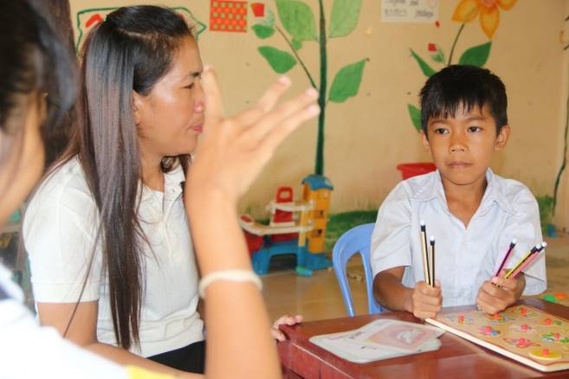
Dy Kimsour, 10 years old, a boy with intellectual disability at Boeung Khna village, Boeung Khna commune, Bakan district, Pursat province. Kimsour is the third son of the five siblings in the family. His parents are the grocery seller in the market in the above mentioned commune.

It was notified that before Kimsour admitted to the integrated class at Boeung Khna primary school, he faced many problems such as school does not accept him to study due to his strange behaviour. Kimsour has difficult in speaking, wearing clothes, bathing and learning. Moreover; he was discriminated and bullying by the people around his community; he often called naughty boy and/or mad boy.
Community check list was used to assess Kimsour’s issues and Goal has been set to improve Kimsure’s problem afterwards.

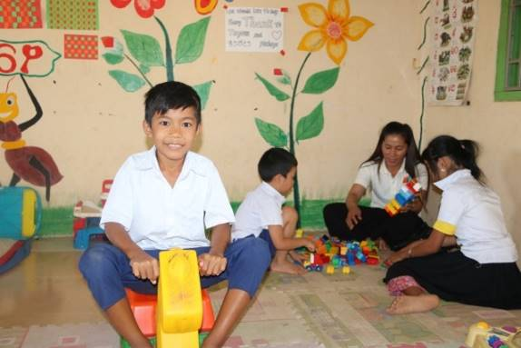
At Boeung Khna primary school; Kimsour has received training on positive behavior and also received special care, life skill training, nutrition, special education, referral for health care. The project also supports him and his family with basic need such as health and hygiene materials, school uniform and counseling.

We observed that; now he can read and write some new words and had more friends and everyone loves him, warm welcoming by the people in community. He now forgets all the negative attitudes/feelings that he had before. Kimsour has much improvement on daily activities, getting well in touch with other students, better health condition than before; and he also can help the family with some housework! There is no more discrimination toward him; due to people have a great understanding on inclusion through awareness raising about disability and other related law by the project.

The improvement of Nat Ratana

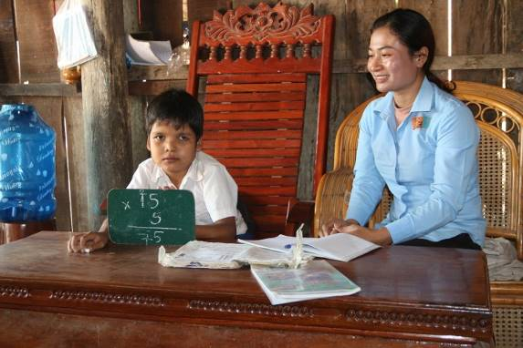
Nat Ratana, 11-year-old boy, is living at Talo village, Talou commune, Talou Senchey district, Pursat province. Ratana is Intellectual disability and low vision youth. He was born in a poor family with 2 brothers and a sister; his parent is a farmer.

It was notified that before Ratana has known Daycare rehabilitation centre of DDSP he faced many challenges such as difficult in seeing, have strange behavior, slow learning and got sick very often. Project staff did assessment; i.e: goal setting and community check list after problem has been found.

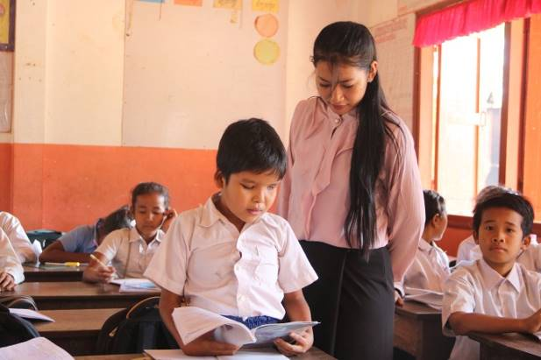
At the Daycare; Ratana has received special care, educate on social communication, life skill training, got nutrition, delicious food, special education and attend many social activities such as children rehabilitation retreat, International Day for People with Disabilities and lots of social interactions. The project also supports Ratana and his family with basic need such as water ceramic filter, blanket, school uniform health and hygiene materials.

We observed that his family now have much improvement with livelihood improved, Ratana now can communicate well, has better health condition and also much more independent with his daily activities living.
Especially he had more friends and every love him, close relationship from his family and other people in her community.

Name and signature of the representative of the organization:
We declare that we have read the information supplied in this report and the information given is clear and correct and all activities and expenditure we agreed as reported.
DDSP’s representative Pheng Samnang, DDSP Director

Signature and official stamp


