GRANT REPORT FORM

SBCF ref number: Date received:
(for office use only) (for office use only)

Section A: Grant Recipient
6
A1: Name of grantee organisation

Disability Development Services Program (DDSP)

A2: Contact information for person completing report

Contact Name/ Title | Samnang Pheng,  Executive Director | Address | Peal Nhek II village, Sangkat Phteh Prey, Pursat City, Pursat province, Cambodia.
Telephone | +855 (0) 52 951 495  +855 (0) 17 872 199  +855 (0) 15 440 036 | E-Mail | Samnang65@yahoo.com
Website | www.ddspcambodia.org | Twitter/ Facebook | Disability Development Services Program (DDSP)

Section B: Project Summary

B1: Project Title | Improving Daily Income of Life of Persons with Disabilities in Pursat
B2: Location of Project (country/ region/ province) | The project location is in Pursat province, Cambodia, South- East Asia.
B3: Grant Awarded (in GBP£) | £58,983.00 (Fifty-eight thousand nine hundred and eighty-three pound only
B4: Project Start and End Date | Started date: 01 July 2019; Ended date: 30 June 2020
B5: Period Covered By Report | 01 January 2020 to 30 March 2020

Section C: Project Activities & Results

C1: Project goal (the overall aim of your project as per your original application).

Persons with disabilities improved daily income and have appropriated job and business through acquiring new skills.

C2: Project purpose (the objectives of the project as per your original application).

To achieve the above project goal, the project has identified three specific project objective as the following:
- Objective 1: By the end of 2021, persons with disabilities and/or their children accessed Inclusive Training Center/vocational training and employment for appropriate job placement with business and private sectors;

- Objective 2: By the end of 2021, families of persons with disabilities increased income through income generation activities and SHG support;

- Objective 3: By the end of 2021, DDSP improved the capacity on service integration, business development, job placement and more sustainability.

C3: Project activities undertaken (please describe what you have done during the reporting period to address the need(s) you identified in your project proposal? Please explain any variances in relation to the planned activities and timescales?).

Here are the project results during the project period:

Objective 1: By the end of 2021, PWDs and/or their children accessed Inclusive Training Center/vocational training and employment for appropriate job placement with business and private sectors.
During this period of time, the project has resulted as the following:
- Project orientation:
In July 2019, DDSP has been completed the Project orientation meeting was conducted to introduce the project objectives and activities for community leaders and local authorities, who are the key persons of the project beneficiaries. Relevant Government officers from Department of Social Affaire Veterans and Youth Rehabilitation, Department of Education, Youth and Sport and NGO staff were also invited to participate the meeting to aware of the project activities. There were 25 persons attended the meeting. The meeting participants were very delighted with the project approval. The project orientation was also done to the target communities as well.

- Skill trainings at the Sir Bobby Inclusive Training Center:
During this reporting period; the project continuing the same activities such as English and skill trainings such as cooking, motor-bike repaired and tailoring with the 14 ongoing from of previous quarter (October to December 2019).

There are totally 14 youth with disabilities (10 females) registered to learn skills; i.e: 6 girls with disabilities learning sewing, 3 youth with disabilities learning motor-repaired, 8 youth with disabilities learning cooking which 5 of them from the sewing session. There are 21 students, including children with disabilities; learning English and other six students learning computer. At the same time; project out-reach staff were conducted field work to disseminate the project activities to the communities and identified persons with disabilities/youth with disabilities to learn skills. With the contribution from AVAST Foundation and Light For The World, the sewing room, kitchen and motor-repair room have been built for those youth with disabilities to learn such skills; the project also provided learning materials and equipment such as sewing machine, cloth, scissors, cooking pots, refrigerators and other related materials and equipment_ they were purchased and installed for the trainings.

However; some trainees are often absent due to health problem and poverty. The project referred them to the Provincial Referral Hospital, supported them food and rent two rooms for their accommodation (a room for male and one for female students) during the training.

- Building work of the Center:
Originally, the center was planned to build with the size of: 9m x 20m but according to the the needs of youth with disabilities to learn skills; DDSP has requested to extend the center with another 9m x 9m for accessible part (i.e: elevator, ramp, toilets and accommodations) as the additional from the original project proposal for the following:

- Front Building size 9m x 20m : The front building part has been built in 2017 which funded by AVAST Foundation/Light For The World. According to the needs of persons with disabilities and other vulnerable people in Pursat and the province surrounding; this front building has been built in the purpose of 1) providing vocational skills and related knowledge to persons with disabilities/youth with disabilities and children of persons with disabilities, 2) providing job opportunity for persons with disabilities through employing them and/or job placement; and 3) generating income for DDSP’s operational cost through renting rooms for workshop, trainings and/or meetings to NGOs and Gov’t departments.
- Main Building: SBC funded in building a SBC center on the existing ground floors built since 2017 funded by AVAST Foundation/Light For The World. After building complete DDSP will use the main building for the following purpose:
- Ground floor: will be used for workshop/training and/or meeting rooms.
- 1st floor: will be used for skill training (for example: sewing, electronics (TV/ phone repair), computer and English lesson…)
- 2nd floor: will be used for training/meetings rooms and accommodation.

- Extend part behind the building with size 9m x 9m and building ramp: According to the needs of persons with disabilities on marketing skill; DDSP requested to build this extend part in the propose of for accessible part such as toilets, elevator and ramp and some spare rooms are for accommodation.

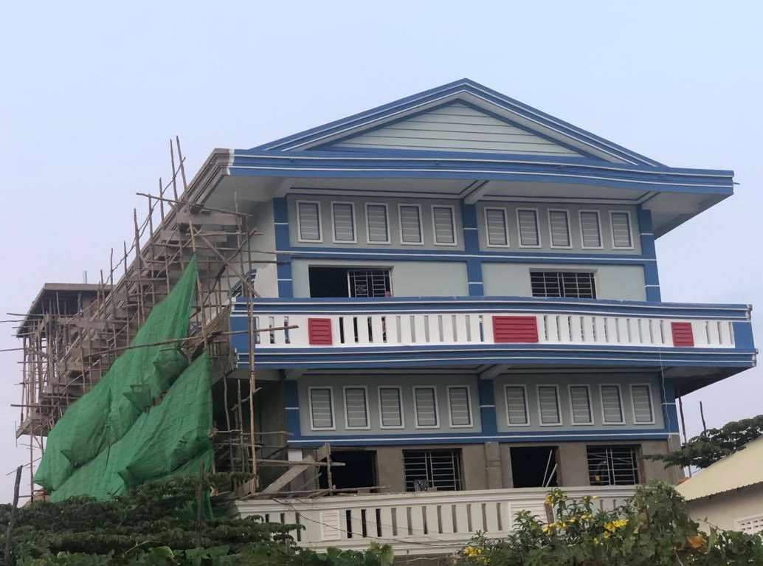
During this reporting period, the construction is focusing on the extension part (with the size of: 9m x 9m) and building ramp; up to now the extension part is finished around 60 % and 80% completed for the whole building. The main part now is starting to paint the final building colours from the top floor to the ground floor one. The elevator company has been identified to purchase. The tiles will be fixed and the missing part will be fixed in the next quarters.

The building project expects to be completed in end of March but because of lack of men-power, construction materials not supply on time and the pandemic of COVID-19, is far behind the schedule. it is requested to delay until the mid of July 2020.

- Rights/Law Dissemination:
There were 6 awareness-raisings, on the Rights of PWDs and Child; have been conducted during this reporting period. There were in total 115 participants (75 female) from 6 different villages. Among the total participants; there were 63 persons with disabilities including 37 female participated the event. The disseminations were conducted as the following:

No | Date | Place | Participants
1 | 16 Jan 2020 | chamka Our village, Tapaeng Cheng commune | 18 participants,14 female and 4 male
2 | 17 Jan 2020 | Roleab, Sangkat Roleap | 25 participants, 15female and 10 male
3 | 20 Jan 2020 | Veal villages, Samrong commune | 18 participants: 13 female
4 | 21 Jan 2020 | Prek Phi village, Samrong commune | 20 participant: 11 female and 10 Male
5 | 24 Jan 2020 | Ang Krong villages, Samrong commune | 26 participants: 18female and 8 male
6 | 25 Jan 2020 | Both Romdoul village, Pteh Rong commune, Talou Senchey district | 13 participants: 4 female and 9 male

There were 20 trainings conducted for both youths with disabilities at the Center and members of the SHGs from the 20 communities,100%achived against to project target. A Total of 455 participants (297female) were attended these training course, which 270 are persons with disabilities.

The main purpose of the dissemination is to aware the Law on the Protection and Promotion on the Right of Persons with Disabilities and Inclusive Development; especially Inclusive Commune Investment Plan. The Law consists of 14 chapters and 60 articles includes general provision mainly on definition on disabilities, Disability Action Council and Disability Right Administration, Livelihood, Physical and Mental Rehabilitation, Health Care and Prevention, Public Accessibility, Education, Employment and Vocational Training, Incentives, Election, Persons with Disability Fund, Implementation of International Treaties, Penalty Provision, Transitional Provisions, and Final Provisions; Disability Inclusion in Commune Investment Plan also included. The meetings started from mid of October 2019 to late of January 2020. The verbal pre-test was made as well to check the participants understanding_ it was telling that: poor understanding: 70% and little understanding: 30%. After the sessions; the participants have improved the understanding a lot on the Law as well as the disability inclusion into the Commune Investment Plan. The post-test was also done to measure their comprehension; resulted: poor understanding: 25%, medium: 45% and good understanding: 30%.

We observed that persons with disabilities in the communities improved their confident, they are brave and dare to talk during they are invited to attend the SHG and/or Commune Monthly meetings; raising challenges/difficulty they have faced at their daily life, the persons with disability representatives also commit to participate the monthly Commune Invest Plan meetings and will raise what they have faced for their daily life in the meetings.

Challenges: There were less participants than expected due to harvesting season, community members were busy with daily routine tasks and many of PWDs were difficulty with transportations to come to the meetings and/or events. However; their family members were asked to participate instead.

- Business concept/plan and Marketing Training: This one-off training was conducted in Battambang on 6 March 2020 for 18 staff members (11 female) of DDSP which is focus on business concept and small and medium entrepreneurship and handicraft, business and handicraft formation and its structure, business by-law and regulation, business chain, financing and financial report, business plan, register and taxation, guideline/policy and other legislation supporting the business and case-study. The objective/expectation of the training is to creating businesses/social enterprise by NGOs, how to support the small and medium social enterprise for persons with disabilities, and urge DDSP to have a sustainable financial resource by creating a social enterprise. Brainstorm, explanation, ask and answer questions, and slide show were used during the training.

The trainer also asked the participants to think of the local related businesses such as marble handicraft, producing oranges fruits by forming the community oranges-farm. Business needs to be think of establishing producer groups, type of businesses/handicraft, and its structure, procedure/by-law, financial report and sources, specific business plan and so on.

After the training the staff has a great understanding on business and marketing concept. We would have a proper business plan for our organization for generate income at least to secure our operational cost and providing job employment, skill and knowledge for our persons with disabilities at the Inclusive Training Center which recently supported our sincere donors.

- Round table meeting workshop: the training was conducted on 05 March 2020 in Pursat, there were 28 participants (8female) from the 20 target villages and including landmine survivors participated the training. The workshop was greeted by Mr. Pheng Samnang and Mr. Rin Narith, Deputy Director of Department of Social Affaire Veterans and Youth Rehabilitation. Mr. Narith mentioned on the good collaboration between the department and DDSP and the contribution/involvement of DDSP to support persons with disabilities in Pursat so far; he also asked to the participants to pay attention to the training facilitator during the training if they have questions or clarification. The training Consultant introduced the participants, purpose and content of the round-table meeting workshop and he encouraged the participants to understand on how to analyse the challenges and difficulty and find out the solution, analyse what are good and what are not good, what are the strength and what are weakness. The main objective to get the participants to improve their understanding on how to increase the daily income through appropriate business along with their physical disability.

The training was discussed on income generation concept at the community level with the relevant activities to generate income through establishing agricultural business_ from the very small to small and medium, understanding on business concept, production chain, finance and capital for investment, business plan, communication and business networking, business guideline and other relevant legislations to support the business. The trainer also shared the success cases of some communities in and out of countries to the parcipnats. The training participants selected two agricultural businesses, fish raising and home vegetable growing; for the technical detail discussion_ i.e: economic analysis on weakness and strength and find out the appropriate solution to the weakness which they have faced. After discussion; there is no major challenges or obstacles for the above mentioned businesses.

As a result; the participants had a great understanding, enjoyed and very much interested in the training as they asked a lot of questions and fully participation. There are 9 participants planned to do home gardening and 4 other participants planned to do fish raising. They committed to start between April to June 2020. At the same time; the trainer contacted the Consultant of Agricultural and fishery to provide the fish seed for the 4 voluntary participants who going to do fish raising. It is noted that it was a great meeting event even though it was short time as not even achieved the expected result but also adding value of the way to increase income for family’s economic sustainability and changing their attitude to focus on doing businesses.

Objective 2: By the end of 2021, families of persons with disabilities increased income through income generation activities and SHG support; ​ ​
- SHG Capacity building: During the reporting period, DDSP’s conducted 2nd capacity building training to the SHG Leaders were conducted on 10th January 2020, 30 participants (8female), from 20 villages, different members of the community leaders. Here is the comprehension check of their understanding before and after the training: Poor: 30%, Medium: 55% Good:15%, and Very Good: 0%; Post-test: Medium: 35, Good: 45%, and Very Good: 20%

There are two trainings of the whole project; i.e: 1st training was conducted last quarter; on 18 October 2019 and the 2nd was conducted at the above schedule. There are two full-day training for each training. These two full-days training aimed to strengthen/build the capacity of Self Help Group Leaders from the 20 target villages to work with/for persons with disability and their communities. The topics of the training included: Leadership and management, way of communication, facilitation skill, bookkeeping and report writing. There were 59 SHG Leaders (13 females), in total; invited to the training. Pre and post-test has been done to assess their comprehension on the topic. Here is the average result of the training:
 | Poor | Medium | Good | Very good
Pre-test | 30%, | 45% | 25% | 0%
Post-test | 0%, | 24% | 51% | 25%

As a result; The SHG Leaders improved their management and leadership aspects as they now can do: conduct monthly and urgent meetings, solve the problem between community members, conduct the community to establish community policy/regulations, record and doing book-keeping by themselves much better than before.

- Monthly meeting participation:
The project maintained to support 25 Villages Disabled Representatives (members of SHG Leader committees) to attend the monthly meeting at Commune Councils to report the result and share concerns/issues of their community. The common challenges that the community faced are lack of fund for doing business, lack of food, lack of health care, shelters and so on. At the same time, 7 Communes Disabled Representatives (Commune Councils) were supported to implement their out-reach work and follow-up the communities of persons with disabilities. The community out-reach staff have very good connection and support from the SHG Leaders and Local Authorities to implement their field work for the communities.

- Social Saving Fund provision: During this reporting period; the project provided social saving fund contribution to 20 SHGs among 25 SHGs for maintaining their community activities. The fund release meetings were done at the commune halls or at the communities where is convenience for most of them; Commune Councils Representatives, village Chief and the three Community Committees of each Community were invited to participate the meetings to ensure the accountability and transparency. 20 communities were selected to release fund due to two of them have quiet good resource and other 3 communities not function well enough the fund was not released unless their committees commit to improve their community’s status. The fund with the total amount of $4,625 (100% done) was released to each SHG as the following schedules and places:
1. On 23rd March: The fund with the amount of $1,850 was released to 5 communities; i.e: Stoeng Komboth, Bakan, Prek Chambok, Chamka Leu and Krasang Krou.
2. On 25th March: The fund with the amount of $1,850 was released to 10 communities; i.e: O’Tkov, Toul Makak, Bosh Kor, Prey Rong, Botromdoul, Kranham, Prey Kanlong, Bak Chenchhean and O’romchong.
3. On 26th March: the fund with the amount of $925 was released to 5 communities; i.e: Angkrong, Veal, Prek Mouy, Prek Phi and Prek Bei.

- Revolving Fund provision: During this time; the fund was released on 23 March to only 3 families for farming and flowers growing with the amount of $525.
In total, there are 50 vulnerable families including families with landmine survivors to start up income generation activities in order to increase their daily income. They are so pleased to have received the fund after they have been trained so they can practice what they have learned.
PwDs as well as the community members showed self-confident with the SHG and they are actively with the project activities; PwD are also valued by their neighbours. With this revolving fund; the load with high interest rate from the bank was reduced. “we can easily borrow the money from the organization; we just have a guarantee group! But for the bank, if we are persons with disabilities and elderly persons they do not allow us to borrow the money” One of the SHG member said.

So far; it is really productive for the animal raising like chicken and pig raising, grocery’s and some crops but cassava, Longan, sugar cane tree and orange trees, expected to have yield at late of the year (November or December).. The 50 families with business as in the table:

Business | # of family | Business | # of family
Long green bean and peanuts | 12 | Planting sugar cane tree | 2
Planting corn | 8 | Watermelon | 2
Planting cassava | 8 | Selling fertilizer and planting orange tree | 1 + 1
Planting longon | 3 | Growing flowers | 3
Checken raising | 5 | Pig-raising | 2
Grocery’s | 2 | Making khmer white wine | 1
Challenges: However; since January 2020, daily selling business; example grocery’s is facing huge problem as people stay home always to protect themselves and their communities from COVID-19 pandemic. Another issue; community facing with the very high temperature at the moment and it is too draught and lack of water source for daily use.

Objective 3: By the end of 2021, DDSP improved the capacity on service integration, business development, job placement and more sustainability.

Project staff have been trained on Understanding and Addressing Behavious, Speech and Language Therapy by the Technical volunteers from the university in UK and USA. The Agri-Lab was also provided to our project staff by the partner organizations in the country.

At the same time; project staff have been supported to attend the meetings of NGOs in the province and out of provinces to share experiences and learning new skills from them.

In generally; the project is going smoothly and have not much variance but just very few indicators less than plan. However; the Laundry learning skill has not been done due to the limitation of the budget.

- International Conference Participation: The project also contributed to support DDSP Representative, Executive Director; to attend International conference in Vienna, Austria from 19 to 21 February 2020 to learn on the best practices of International NGOs, DPOs businesses and private companies helping/enabling people with disabilities working at their working places.
About the Zero Project: The Essl Foundation started the Zero Project in 2008. The mission was to work for a world without barriers. Zero stands for zero barriers. This means a world where people with disabilities are not prevented from doing the same things as people without disabilities. To do this, the Zero Project relies on the UN CRPD. UN CRPD is short for United Nations Convention on the Rights of Persons with disabilities.

The Zero Project works on innovations for persons with disabilities. Part of their work is to inform others about these innovations. The Zero Project has a big network of experts with and without disabilities. The members of the Zero Project come from 180 countries. The Zero Project team finds Innovative Practices and Innovative Policies. These are great innovations that support persons with disabilities. The Zero Project works together with different persons and organizations around the world. Then they inform others about these Innovative Practices and Innovative Policies.

This year Zero Project Conference was conducted on 18 – 22 Feb 2020 with the topic of Inclusive Education. There were 75 Innovative Practices and 11 Innovative Policies from 54 countries invited to participate this important and interesting Conference as an International study on the implementation of the UN Convention on the Rights of Persons with Disabilities – “For a World without Barriers”. If possible; DDSP commits to participate this annual International Conference in order to improve his work for persons with disabilities.

C4: Project methodology (please explain how you delivered the activities described in C3 e.g. by training local people, using volunteers or outreach work).

DDSP uses with twin-track approaches_ i.e: implement the project activities by our out-reach staff and through our partner staff aiming building their capacity to work for/with persons with disabilities; for example: Government teachers, Local Authorities, Community Leaders, Disabled Person Representatives who our volunteers to work with/for their communities of persons with disabilities and other vulnerable persons.

C5: Milestones achieved (please include significant milestones reached with dates).

In generally; the project is going smoothly and on track. It is mostly done only activities of support community leaders for monthly commune meetings and commune councils to do their outreach work with persons with disabilities.

For the building work will behind the schedule: It is farther behind the schedule due to a few challenges such as lack of labour force, construction materials supply and COVID-19 pandemic during the construction. However; the construction company requested and commit to finish at the late of June 2020. Hence; fixture, tiling, utility system connection and the extension part is on the process. But the lift installation will be installed one month after the building finished.

According to above DDSP would like to request for an extension to finish the building until mid of July 2020.

C6: Project results by Objectives for the year 1 (2019-2020)
Project Output Indicators by objective 1 (these should match the immediate difference you expected the project to make in your original application) |  | Project Output Results (these should reflect progress towards achieving the project outputs during the reporting period)
 | - 20 Students identification and announcement | It is done.
 | - Conducting ongoing training on English and Computer skill with 30 students (20 for English class and 10 for computer class) | It was done. It is now postpone due COVID-19. The new identification will be made after COVID-19 calm down.
 | - Conducting training on Rights of PWDs and Child's rights and disability inclusion for YWDs and other 20 communities | It is done_ 25 persons attended the training and other 20 communities have been trained. Completed!
 | - Preparation and conducting training on Business​concept/plan and Marketing for DDSP and key persons (25 persons) | It was done_ there were 18 staff participated due to limitation of the budget. Staff have a great understanding of topic trained.
 | - Develop IEC material/Promotional material for the centre/ Printing, meeting etc…(3 bill-boards) | It will be done in the last of quarter of the project (Apr to June 2020) due to the discussion of design.
 | - Develop and purchasing Training materials and equipment (1 set) | It is done_ materials and equipment for cook and motor-repair has been purchased.
 | - Setting up the Moto / bicycle/ wheelchair repair VT workshop (1 set) | It is done and it is on the process of learning skill. However; it is needed to be improved as it is so basic and too narrow
 | - Conducting assessment YwD for Laundry learning skill (5persons) | It is postponed due to the limitation of the budget
 | - Organizing the Provincial Roundtable on income generation for landmine survivors (1 time with 30 ps) | It is done! It was conducted on 5 April 20. There were 28 participants participated.
 | - Assessing/​recruiting YWD and support them for learning skill | It is done for the first round of learning skills and ongoing to select the new YWDs for the new course.
 | - Providing job coach for YWD (15persons) | It is not yet done as the course not yet finished
 | - Follow-up/monitoring and SHG strengthening | It is ongoing activity.

Project Outcome Indicators by objective 2(these should match the lasting change you expected the project to deliver in your original application) | Project Outcome Results(these should reflect progress towards achieving the project outcomes during the reporting period)
- SHG leaders capacity building on leadership, community organizing and disability inclusion | It is done in October, there were 29 persons participated the training.
- Support SHG Leaders/ VDPR to participate monthly CC Meeting | It have been done and ongoing_25 persons have been supported
- Gasoline support for CCs for their out-reach work with SHG | It has been done and ongoing_ 7 CC members have been supported.
- Providing grant contribution for community social saving fund | It is on the process of document development_ it was done!
- Providing revolving fund for PWD/ their families for income generation activity. | It was done_ all paid.
- Follow-up/monitoring and SHG strengthening | It is ongoing activity.

Project Outcome Indicators by objective 3(these should match the lasting change you expected the project to deliver in your original application) | Project Outcome Results(these should reflect progress towards achieving the project outcomes during the reporting period)
- Staff capacity Development (training on disability inclusion, business lab, business strategic plan, etc…) | It is on the process of searching the sources where to learn from. Business plan and strategy was trained to most of the staff.
- Business strategic development training. | It is the process of searching the sources where to learn from and it will be done in April 2020.
- Participating CBR Congress and the Conference of workability both Asia and​ International… | The CBR Congress was missed due to budget and time constraint. However; representative of DDSP participated the Zero Project in February 2020 in Vienna, Austria.
- Networking (meeting with partners​​_ provinces, PP…..) | It has been done and it is ongoing.

C7: Project beneficiaries (please explain who has benefitted from this project so far? This should include both their profile e.g. age, gender etc and their circumstance e.g. levels of poverty, health, marginalisation etc).

The project beneficiaries are both children and adult, male and female, all ages and all types of disabilities. However; the project designed to support two different parts of the project; i.e: 1) Self-Help Group of persons with disabilities, at the rural landmine affected areas; who many of them are landmine survivors and 2) youth with disabilities and the youths of persons with disabilities who are from Pursat and other provinces nearby Pursat province. They are all from the very poor families and the people with special needs.

Total direct beneficiaries of the project at this report period are 341 persons (96 female). These includes 39 youth with disabilities (15female) who are direct benefiting from the Center. Not only persons with disabilities benefit from the project but also their family members and their community as a whole_ approximately: 1,705 persons as the indirect beneficiaries.

C8: Beneficiary involvement (how have the beneficiaries been involved in the delivery and monitoring of the project during the reporting period?).

Beneficiaries, especially; Village Disabled Persons Representatives/ SHG Leaders were invited since before this project designed; i.e: to do assessment and collect all the needs from the community members. They are the key players to deliver the project activities with the local authorities and our project staff and giving feedback to improve the working quality. They have been be very much involved in project monitoring process .

C9: Equality (please explain how project activities, support and benefits have been open to all who need them irrespective of who they are? Also explain what steps you have taken to ensure those with additional needs e.g. people with a disability or young mothers have been catered for and fully included in the project?).

This is ongoing activity. Every single of community members has benefited from this project both direct and indirect. As person with disabilities, especially women with disabilities; are the most vulnerable people and discriminated by the society and unequal opportunity with persons without disability in Pursat as well as the whole Cambodia. With this unfair circumstance; we have been working to promote their fully participation, especially on accessing to information, health care, social-economic services and job opportunity.
Not only the persons with disabilities but young women with disabilities are very much benefited from this important project. The role of young women with disabilities are to be particular importance in this project because women are usually responsible for daily household activities. They are promoted in all aspects of this project, in particular in community-level management_ DDSP has encouraged young women with disabilities to have positions in the village disabled people's committees and 16% of committee members are women with disabilities; they have been encouraged to play main roles in community facility.
The project will ensure women's participation in training and awareness-raising at community level. In addition, women are well-represented per DDSP Gender policy. The project also promotes women participation at commune council and district level; their role is to facilitate and involve in the project design. 75% of meeting participants are women. DDSP has two women of the 5 Board of Directors and 11 of 22 DDSP staff are women and four them are young women with disabilities.

C10: Partnership & coordination (please describe the role and contribution of any partner that has been involved in the project? Please also explain how you have coordinated your activities with those working in the same or a similar field/ location e.g. other NGOs, UN agencies etc?).

The Local authorities; especially Commune Councils, the Disabled Representatives and the most relevant Governments such as Department of Social Affaire Veterans and Youth Rehabilitation (PoSVY), Department of Education Youth and Sport and Provincial Referral Hospital are our project partners and they are very much involved the project implementation and very supportive partners.
During this period of time; All Ears Cambodia come down to Pursat in the three-month basic to provide hearing treatment and hearing aids to our persons with disabilities and who are having hearing difficulty. There are 87 persons with hearing difficulty coming to have hearing treatment and received hearing aid.
DDSP also worked very closely with all relevant NGOs in and out provinces and both national and international level; i.e: All Ears Cambodia, CDMD, EPC, VIC, JC, ICRC, EXCEED Worldwide and Rabbit School to share information, refer, exchange ideas and getting assistive devices.
These important Partners and Key Stakeholders contributed to the project activities as the following:
- Commune Councils and Disabled Representatives: direct assisting with the project implementation and monitoring at the community work; at the same time they will report and share concerns for feedback to improve their community work;
- PoSVY: Providing in kind support, counselling, advices and technical support on disabilities. DDSP respects him as a technical advisor to the project implementation. DDSP’s working place is in the compound of PoSVY.
- Department of Health/Referral Hospital/Health Center: Providing working place for our Physiotherapy clinic for children with disabilities at the provincial level. Health Center helps the project with providing health, hygiene and sanitation training to the community.
- Department of Education, Youth and Sport: supporting with the Inclusive Education work for children with disabilities to go to schools; they also support us in setting up the integrated classes of children with intellectual disabilities/ childrenwith special needs.
- Department of Agriculture: Providing training on skills/knowledge related to agricultural businesses such as home gardening, animal management and other related businesses.
- INGOs and LNGOs: Supporting on technical aspects for assistive devices, relevant rehabilitation services and information such as wheelchairs, walking sticks/frames, referral for rehabilitation and sharing information or data related to disability.

C11: Project management (please explain how the project has been managed and by whom? Please document any significant management issues that you have had to deal with during the reporting period?).

The project is led by a Director who is advised/governed by 5 boards of Directors and managed by the CBR Project Coordinator which supported by 1 project field staff; at the community, the project facilitated by Disabled People Representatives and supported by the Local Authorities, Commune Councils who are working very closely with the members of SHG.

At the Inclusive Training Center of Sir Bobby Charlton, managed by the Center Manager which assisted by other 4 staff; i.e: 2 teachers of English and Computer, 1 Cook Trainer, 1 Motor-repair technician and 1 Security Guard). An administrative/finance officer will assist with admin and finance work as well.
The project will be implemented with annual action plan, quarterly, monthly action plan and weekly plan. Monthly meetings have been conducted to update the progress of the project and review/making plan for the next month. Project field staff and their Project Coordinator conducting their outreach work every week for both project implementation and monitoring of the activities that they have been done at the communities. Executive Director does his field monitoring at least twice a month to every components of the project; then he will feedback for improvement at the staff monthly meeting.
Board of Directors and all DDSP’s Donors are very welcome to visit every part of the project of DDSP but they would inform our management team at least three days before they come in order to avoid the duplication schedule with other visitors’ schedule.

C12: Project risks (please set out below any risks you have encountered during the reporting period and what action you have taken to mitigate against the risks impacting on the project?).

There main risk of this period of time is the community affected by the COVID-19 and everyone afraid of this terrible serious disease.

C13: Safeguarding (please detail any safeguarding issues you have encountered during the reporting period, your response and the final outcome?).

DDSP is a non-profit organisation and we are accountable for all related stakeholders including donors, development agencies, government partners, local authorities, beneficiaries as well as al DDSP staff. To ensure and safeguarding ourselves as well as our stakeholders we have developed series of policies such as organizational By-law is the main key most important document to tell our direction and it is the premier document of the organization, Staff Policy tells us what we will be accountable for our staff and what they should account for the organization and our beneficiaries. Procedure and Financial Policy tells us how we manage the financial resource in effective way and transparency. To come along with these; we also have Board of Director Policy, Conflict of Interest and Grievance Policy, Child Protection Policy, Gender Policy, Beneficiaries/Client/PWDs Policy and Procurement Policy and some other specific regulation and policies at the community level to be the guidance for our staff as well as beneficiaries to follow. These important documents are reviewed every two years if required.

During this report period, the project has no any safeguarding issues encountered.

Section E: Project Budget

PLEASE ATTACH A COMPLETED FINANCIAL REPORT SPREADSHEET FOR THE REPORTING PERIOD.

E1: Financial Report Narrative (this section should be used to explain the financial report in more detail. This includes: any under spend/ over spend, any variance of more than 15% between budget lines in your approved budget and any issues relating to exchange rates and inflation).

The budget of the project is divided into two parts; i.e: the budget for the building work (construction of the Center) and the budget for activities work at the landmine affected communities. They both are on track and below is the summary report so far:

The total budget expenses for this reporting period is $16,683.90. This is included the main budget lines as the following:
- Conducting training in PWDs’ and children’s rights for communities: $146.81
- Training on disability inclusion: $138.71
- Training English: $300
- Training DDSP staff on Business concept and marketing: $940
- Collecting/transportation for trainees to come to the Center: $326.44
- Round table workshop on IGA for the landmine survivors: $949.84
- Study support for the trainee on food and accommodation: $1,431.22
- SHG Leaders Capacity Building on Leadership and management: $468.44
- CCs support for their outreach work with the communities: $206.32
- Grant contribution for community social saving fund for 20 communities: $4,567.90
- Revolving fund for Income generation activities: $518.77
- International Conference of Zero Project in Vienna, Australia in February: $1,010.00
- Staff DDSP and trainers support: $5,487.90

Here is the table of accumulation of income and expenses so far
Component | 1st instalment | 2nd instalment | Total | Expenses | Balance
Building work | $81,507.00 | $45, 902. 59 | $127,409.59 | $83,498 | $43, 911.59
Community | $37,467.00 | $18,991.41 | $56, 458.41 | $36,621.97 | $19,836.44
Total | $118,974 | $64,894 | $183,868.00 | $120,119.97 | $63748.03

$43,911.5The remaining budget is high due to the last instalment was transferred in March 11, 2020. This remaining budget will be spent in the next quarter (April to June 2020) _ please see the section H1 for detail activities. Please find the financial report separated sheets in the attach files.

Section F: Service User Stories
F1: Case Studies
Please provide at least one beneficiary case study which illustrates the work that you have undertaken during this reporting period and the results achieved. Where appropriate please include pictures or attach video evidence.

- Success case of Mr. Neang Sath’s family
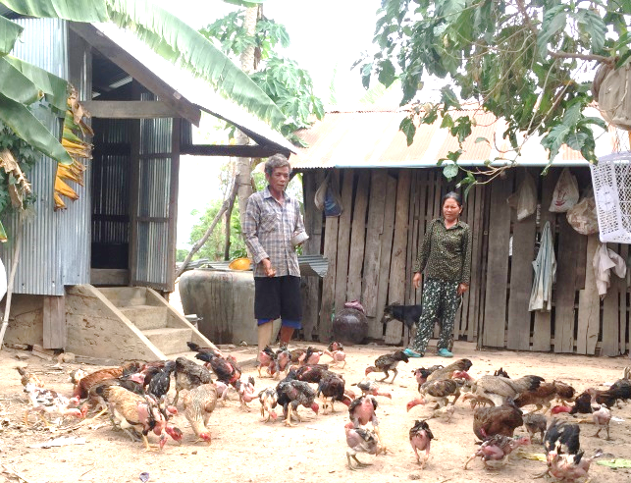
Mr. Neang Sath, 56, years old, his wife’s name is Mrs Ngin Savann, 55. There are 3 members in the family live at Kranham, Pteh Rong commune, Talou Senchey, Pursat province.

Mr. Neang Sath worked as a soldier since 1986 in Kampot province; unfortunately, two years later (1988) he stepped on mines_ his right leg was cut below his knee. He was back to live his family after the accident. He looked after his four children while his wife sold something at the local market to survive. As the income just even not enough to pay for the daily expense they decided to move to the above address. There, he and his children got up early in the morning to the paddy rice field to collect crabs and frogs for food. They had nothing besides farming. Because of poverty; he borrowed some money from the lcoal lender money business with very high interest rate (10% per month). Finally; they had sold their paddy rice field where they earned for many years to pay the debt and they didn’t dare to borrow any others as they had nothing to pay back to the debtor.

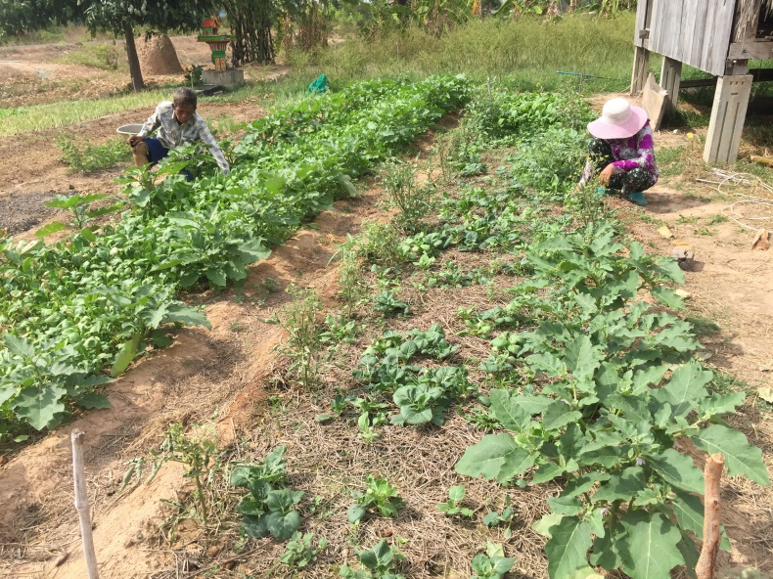
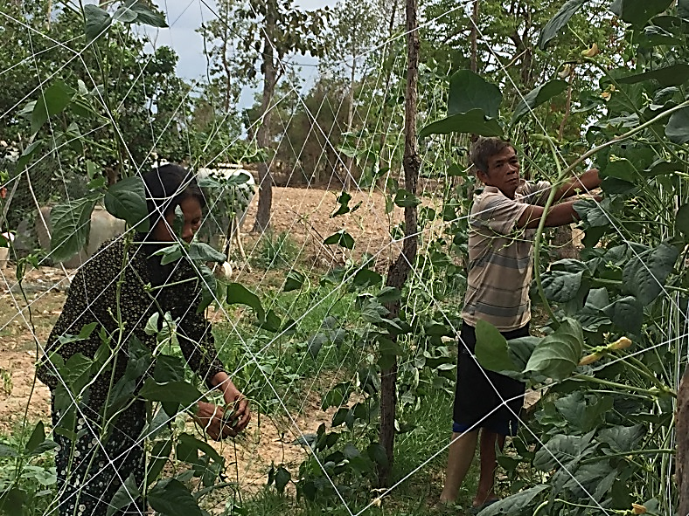
In 2008, DDSP and collaboration with commune councils to form Self-Help Group for persons with disabilities so that they can help and support each others in the communities. Community assessment had been conducted to reponse the needs of its members. So far; his family received knowledge of vegetable growing, animal management, health and hygiene educaiton and materials and been supported to attend the community social activity events. They also receive wate collective system from the project. Mr. Neang Sath as well as his wife are very satified with the organisation for their initiative to form and support Self-Health Group_he follow properly the community policies such as come to regular meetings and follow the community saving role. He recently borrowed the revolving fund from the project for home gardening and chicken raising. Currenly; his family saved at least 20000 to 30000 riels while 60000 to 70000 rield per day in the raining season from vegetable growing and 150000 to 200000 riels from the chicken raising, his wife said. If DDSP presented at his village before that they will not lose their paddy rice field, his wife added.

His family now; not only have more debt but a better living stardard as their daily income increase from the home business supported by the project. He would sincere thankfully to DDSP and their donors who support his family to have a significant change as today. “ Without DDSP; they do not have today. We would like to wish DDSP and all the donors healthy and success” Neang Sath said.

Section G: Additional Information

G1: Other Information

Please detail here any information you think we should know that has not been captured elsewhere in the report.

During the report period; we have some main challenges as the following:
- Lack of food and transportation support for youth with disabilities who are learning skills as they are from the very poor families;
- Lack of food and transportation support for youth and children at the CBR Daycare Center;
- Lack of support for the children with disabilities and children of PWDs to go to schools;
- Over load work for the community activities as we have only two field staff to cover more than 20 communities;
- Behind the schedule of the construction due to lacking of manpower and COVID-19 pandemic;
- PWDs and community still afraid and panic of the COVID-19;
- Businesses of PWDs may face with no marketing and it may affect from the COVID-19;
- During the report period, there is no rain and it was very draught it was affected very much to PWDs who doing vegetable growing, farming and animal raising;
- PWDs are worried about their children learning as the schools still not yet open;
- From the next quarter; the raising season will be, so it may rain a lot and it may challenge to the project implementation;
- DDSP is keen to establish the proper Rehabilitation center for children with cerebral palsy and other people with spinal cord injure but we have limited resources of budget to do so.

Section H: The Next Reporting Period:
April 2020 to June 2020 (July 2019 – June 2020 _ Accumulated)

H1: Planned Activities and Priorities

Please detail here any key developments or activities you plan to undertake in the next reporting period?

The main activities for both building and Community works were almost finished_ however; there are some work listed in the below tables need to be completed for the next reporting period:
- Building/Center work:
# | Activities | April | May | June
1 | Develop IEC material/Promotional material for the centre/design and printing bill-boards | √ | √
2 | Improve the quality of the two poles which found by the technical architecture | √ | √
3 | Completing the extension part | √ | √ | √
4 | Sign the agreement with the elevator company and building the foundation |  | √ | √
5 | Fixing AC and connecting the utility system |  | √ | √
6 | Finish the ramps part | √ | √ | √
7 | Clear out and cleaning |  | √ | √
8 | Making fence of the center |  |  | √

- Activities work:
# | Activities | April | May | June
1 | Working with local authorities to select PWDs and vulnerable people to receive the emergency kits during COVID-19 | √ | √ | √
2 | Conducting assessment/identifying for new youth with disabilities; | √ | √ | √
3 | Counselling and follow-up PwDs and their income generation activities | √ | √ | √
4 | Continue to support SHG Leaders/ VDPR to participate monthly CC Meeting; | √ | √ | √
5 | Continue to support for CCs for their out-reach work with SHG; | √ | √ | √
6 | Support Commune disabled Representatives/CC for their outreach work | √ | √ | √
7 | Monitoring & Follow up both individual families and community meetings | √ | √ | √

Revised date: 21 May 2020
Reported by
Name: Pheng Samnang Position: Executive Director

Signature: Official Stamp:
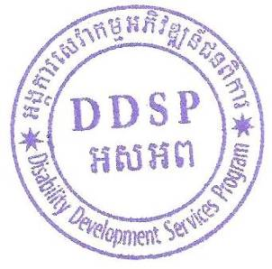

See SBCF’s Safeguarding policy for more information on Safeguarding and the responsibilities of Safeguarding Focal Points

