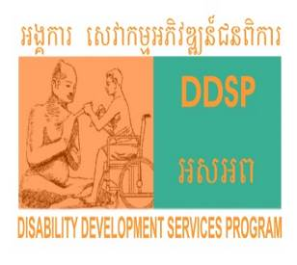

The Sir Bobby Charlton Inclusive Training Centre for Youth with Disability

Program annual Report

(January - December 2020)
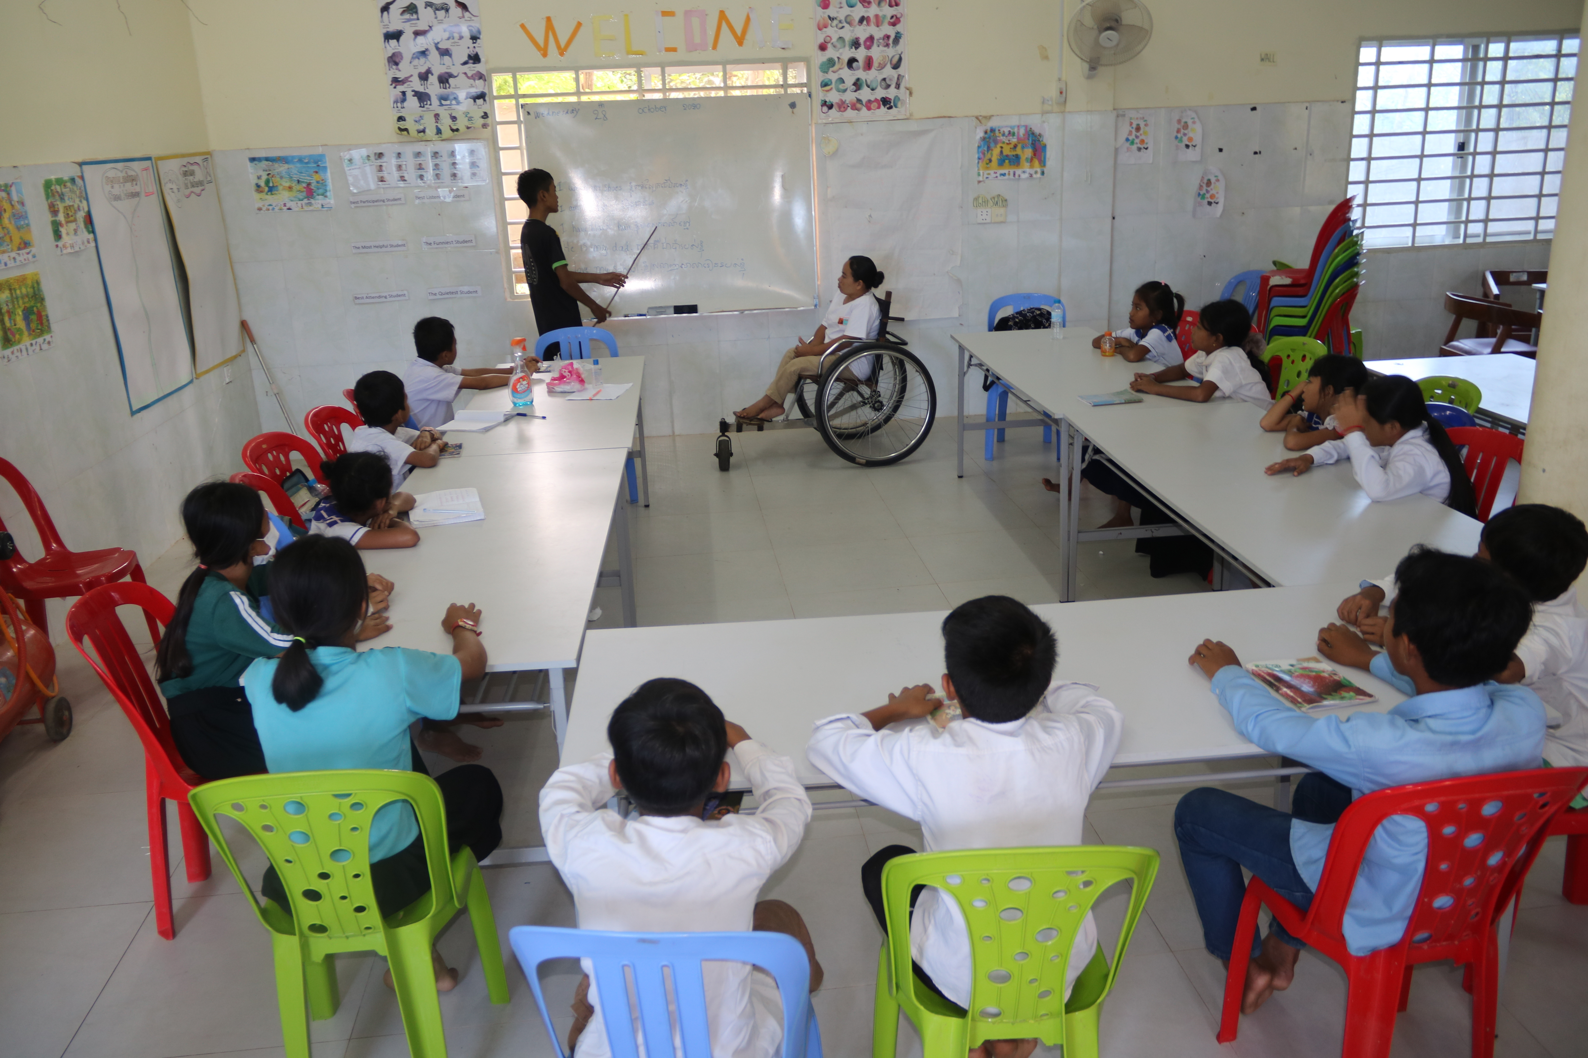
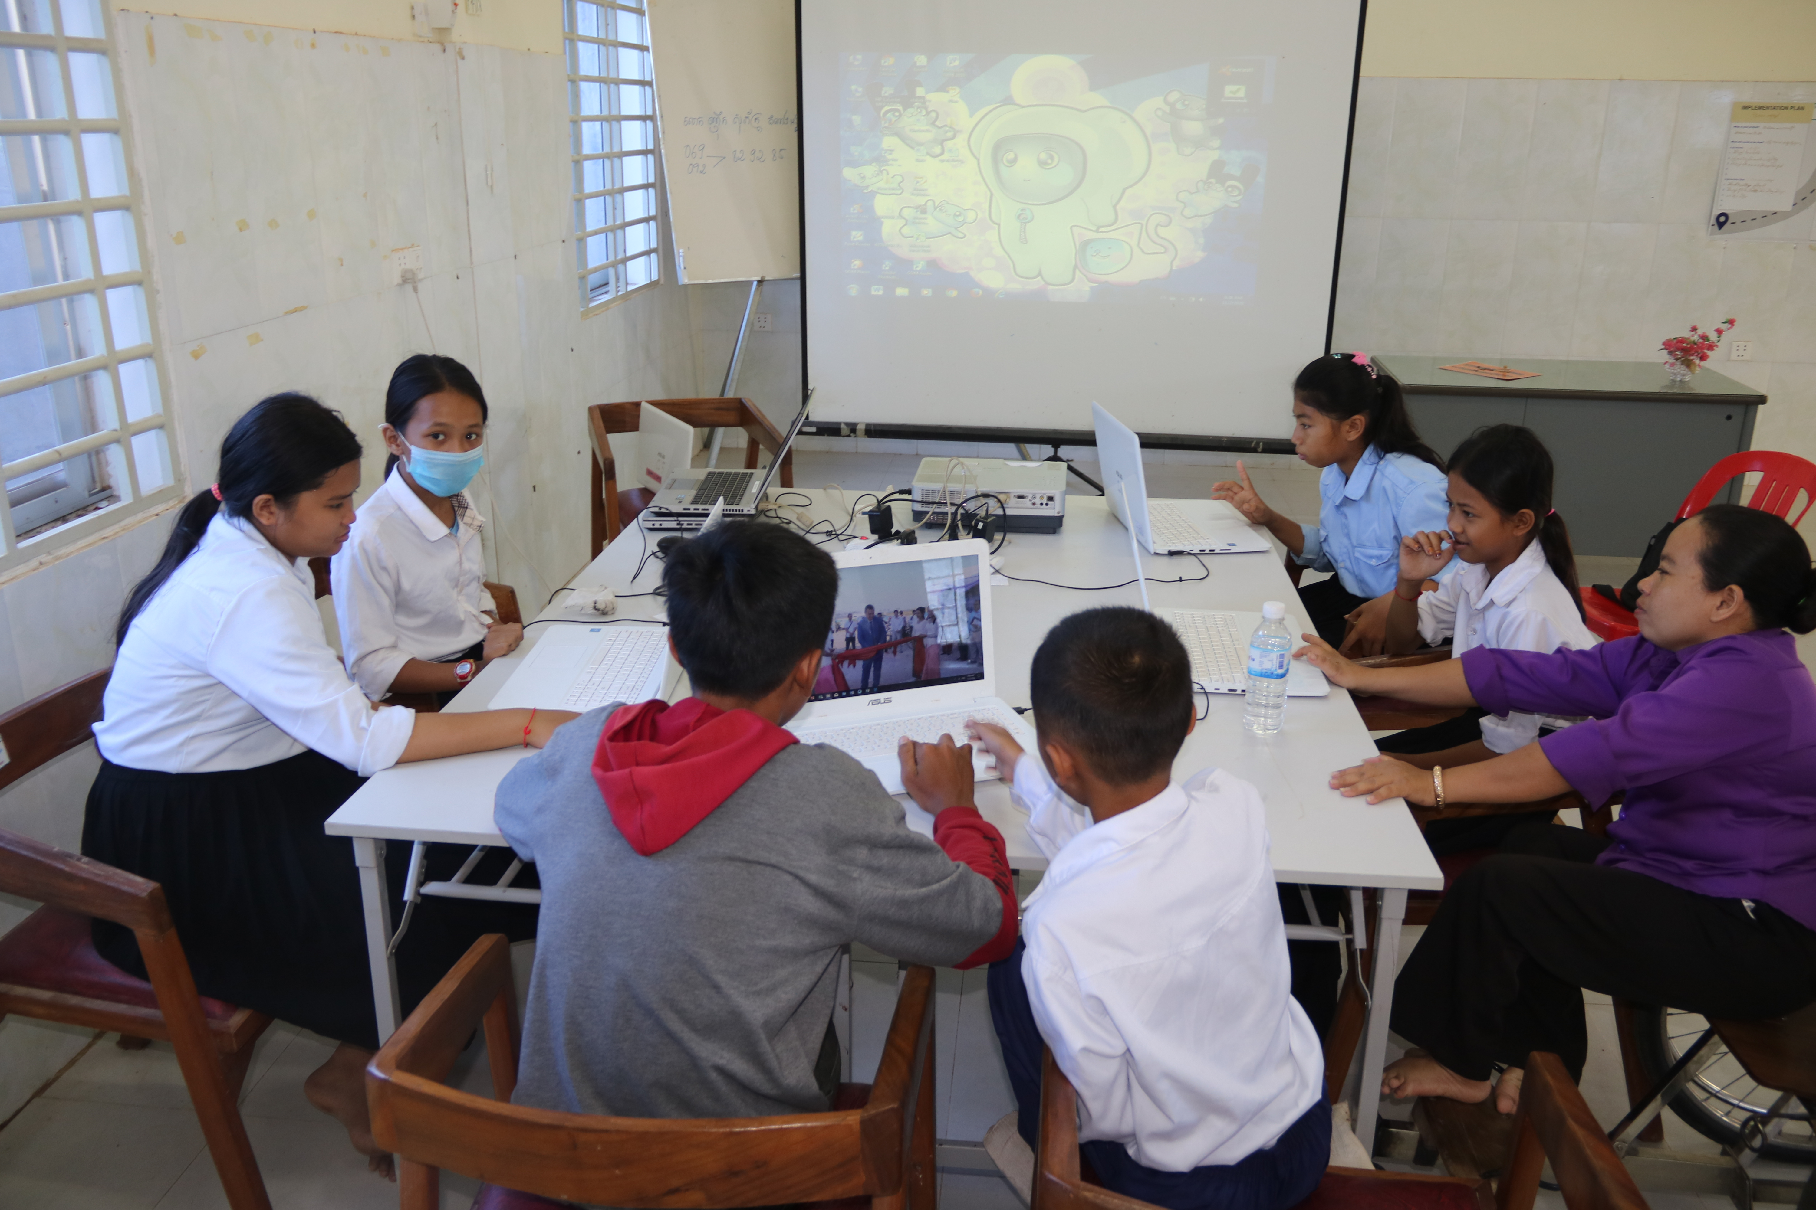

Activities of Computer and English learning at the Inclusive Training Center

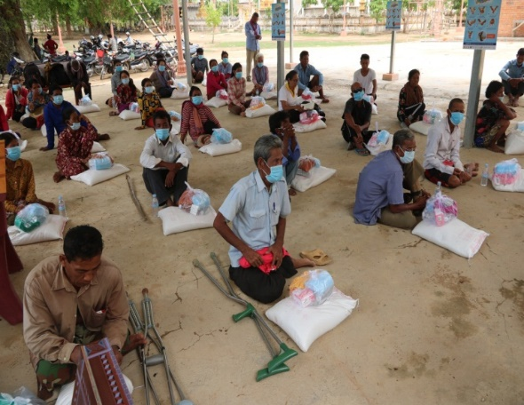
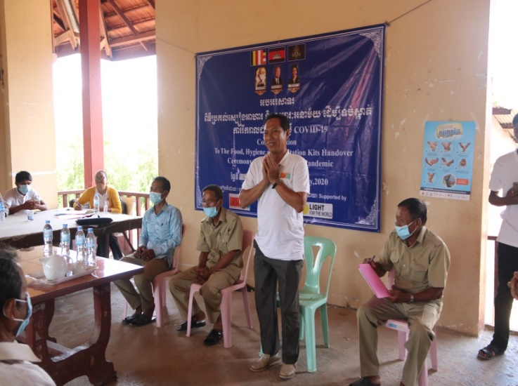

Activities of emergency responses during the COVID-19 pandemic

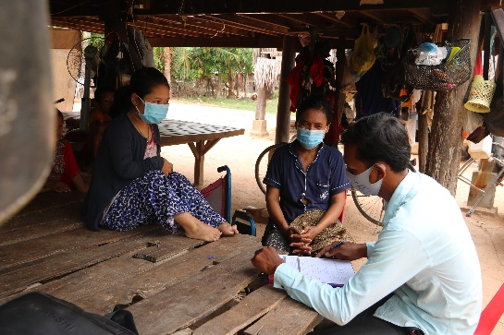
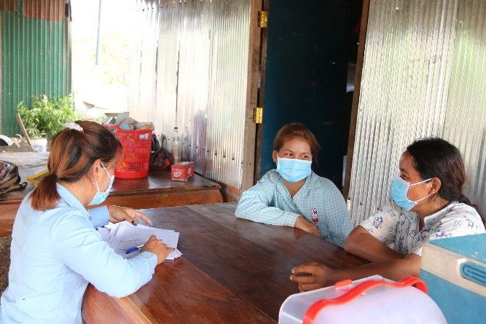

Project field staff did home visit and assessment to the target beneficiaries

Project information
Project Name | Inclusive training Centre for Persons with Disabilities in Pursat Province, Cambodia
Project Number
Supported by | Light For The World
Project Goal | Youth with disabilities and the youth of persons with disabilities have appropriated job and business through acquiring new skills.
Project Objective | - Continue to mobilize support and resources for the training center development and supporting center running cost.  - By Oct'2020, 20 children/youth with disability including severe disability will receive learning and training skills from the training center (skills include: English, Computer, repairs, sewing, kitchen and service training etc.)  - By Oct'2020, 10 youth with disability who were trained from the center receive job coaching.  - Building and strengthening the collaboration with relevant stakeholders such as business owners/employers, government department and NGOs network in Pursat province.  - Community/family have greater understanding about supporting their child with disability development (send their child to the center, support learning at home, motivation etc).
Target areas | Pursat Province, Cambodia

Reporting Period | January 2020 to December 2020 | Approved Annual Budget: | US$5,000
Project Country / Province | Cambodia, Pursat Province | Project Sector | Disability Inclusion/ Inclusive Training Center
Total Expenditure from Jan to Dec 2021 | US$4,983.55 | Expenditure (cumulative) | US$ 16.45

- Project Result Summary againt main activities:

- Project introduction/project launch: A meeting was conducted to introduce the project goal and objective/purpose. There were 32 participants were invited for the meeting, they were including: village chiefs, commune chiefs, VDR and CDRs partner NGOs and DDSP staff were invited for the meeting. Participants of the meeting had a great understanding on the project goal and activities. Local authorities and other relevant stakeholders showed their commitment to get involvement and support the project activities.

- Providing health, hygiene and sanitation messages and materials to prevent PWDs and their families from COVID-19: Through the verbal interview with persons with disabilities, their families and observation by the project staff; it was said that persons with disabilities survived by the support of their care-givers/family members who doing small businesses and/or income generation activities. But, currently; because of COVID-19, their care-givers/family members could neither be earning income nor doing any more business and it caused huge negative impact for persons with disabilities living as well as their families. Here are the challenges they have faced: Lack of food, lack of nutrition, lack of hygiene and sanitation, do not know how to protect from COVID-19, lack of sanitizing materials such as alcohol, gel, face-mask and medicine and etc.

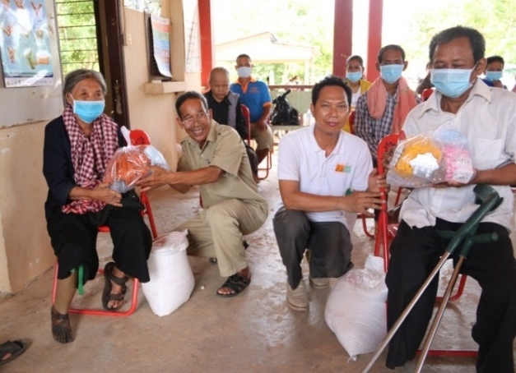
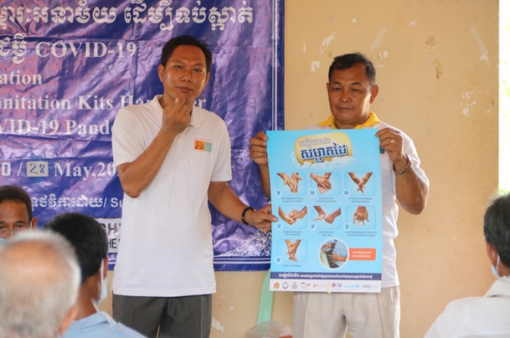
To response to the above challenges and by support from Light For The World; DDSP has collaborated with key role players such as, Department of Social Affair Veterans and Youth Rehabilitation, District councils, Commune Councils, Persons with Disability Representatives, Health Center staff and Police. As a result; 130 PWDs, from 4 different districts_ i.e: Kandieng, Bakan, Krakor and Veal Veng districts; have been assessed and selected to provide the emergency kits. There was other 49 CCs/CDRs and 21 DDSP staff also received this emergency kits. The kits were included: 1) 2 litres of alcohol, 4 pieces of soap, 25 pieces of face-masks, two towels, 4 large pieces of paracitamol and 15kg of rice received by PWDs and 1) alcohol: 1 litre, 1 box of gloves, 1 box of masks, 5 large pieces of paracitamol, cellphone and gasoline support received by CC/CDRs. for two months. Particularly; the 21 DDSP staff received one small bottle of gel, a box of mask and a rain-coat. At the same time; key role players; have given some messages to the participants during the events in order to keep themselves safe from COVID-19 and other diseases. They said: the diagnosis of COVID-19 is that cough, tired, persons with the temperature from 38C up and hard to breath….. The way to prevent is to keep cleaning hands with soap/sanitizing gel as often as possible before and after going/coming from the toilet and after/before eating something and touching bars, toilets, elevators of the public buildings. He/she has to drink safe water, good and well-cooked food, not shaking hands, wearing mask properly when going out to the collecting place of people, and call to 115 for consultation with the doctor if you are not so sure yourself whether you affected by COVID-19 etc…. ​the Police Post officer also toke the opportunity to disseminate the Law on the domestic violation and using drug to the participants and their community. Last but least; all Guest speakers and PWD representatives expressed their thankfulness to Light For The World for their generous support. “This is the huge contribution to fulfill the gaps of the government in order to support the needs of those vulnerable people. We would like to thank you all for having such important project in the province” said of the Director of POSVY of Pursat.

- Community Awareness raising about children/disabled right and Center activities: 11 awareness-raising events about the activities of the Center includes sewing, motor-bikes/wheelchairs repair, cooking lesson, English and Computers has been done. There were another 385 participants (250 female) including local authorities, youth and villagers participated. Participants were very interested in the activities and some questions related to accommodation, transportation and learning fee has been raised by the participants during the events.

Together with the local authorities, community awareness-raisings and new client assessment have been conducted at 11 target communes (i.e: Along Ville, Banteay Dey, Veal, Ptesh Prey, Snam Phreh, Thnout Chhum, O’sandan, Chamroeun Phal, Svay Loung, Koh Chhum and Roleap communes). At the same time, there were 25 persons with disabilities were met and interviewed. As a result; there are 13 interested to learn skill; i.e: sewing: 4 persons, cooking: 1 person, and motor-bike repaired: 8 persons.

- Student identification and Classes enrollment: Project team with the local authorities have conducted project announcement on the skill learning at the SBC Inclusive Training Center both at the schools and house-holds_ 450 children reached and 20 families were assessed. As a result; there were 79 children (45 females) enrolled for learning English and computer. There are 2 shifts classes; i.e: 1) morning shift: there were 34 children (18 females) learning English and 8 children (6female) learning computer; and 2) afternoon shift: there were 29 children (15females) learning English and 8 children (5females) learning computer. Unfortunately; we are unable to manage to run the classes of tailoring, motor-bike repairing and cooking for youth with disabilities due to the funding issue from donors.
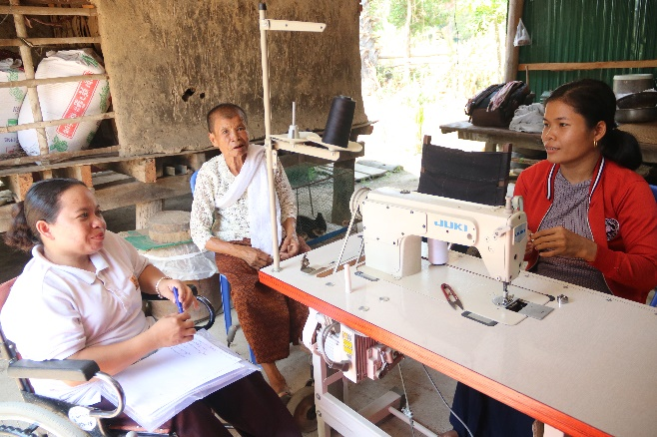
- Project Monitoring: DDSP out-reach staff and local authorities; during this time, 6 trained youth with disabilities who were completed sewing and moto-bike repaired have been followed-up by project field staff. Phone-calls and home visit were also conducted to counselling them and make sure what their plan are and how their business going on.

- Others:
- Garden upkeep and planting: Some plants with pots and vegetable seed has been bought for upkeeping green at the Center and coaching and/or provide students’ skill on growing vegetables.
- Training materials development: Besides, the teaching students and skill facilitation, project staff developed materials (lesson plan and materials).

- Challenges
There were less participants than expected due to the huge problem as people stay home always to protect themselves and their communities from COVID-19 pandemic. Another issue; community facing with the many time flooding to most of our target communities and sometime of the year was very high temperature and it was too draught and lack of water source for daily use.
Because of the unexpected pandemic of COVID-19; many donors facing funding problem and it led to reduce fund for project implementation. DDSP has to cut some activities and some staff and/or reduced the support.

- Financial Report Summary
- Budget approved: US$ 5,000
- Total budget expense in the period: US$ 4,983.55
- Balance: US$ 16.45
Reported date: February 5, 2021
Reported by Center Manager, Checked and approved by DDSP Director,
Mr. PEN Syna Mr. PHENG Samnang

Received, and amended by Light For The World

