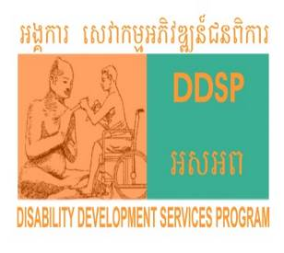

Advocacy and Communication for Change​

Program Annual Report

( Jan– Dec’ 2020)
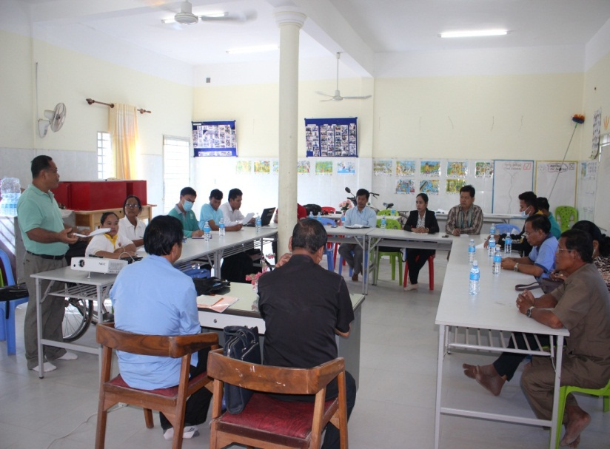
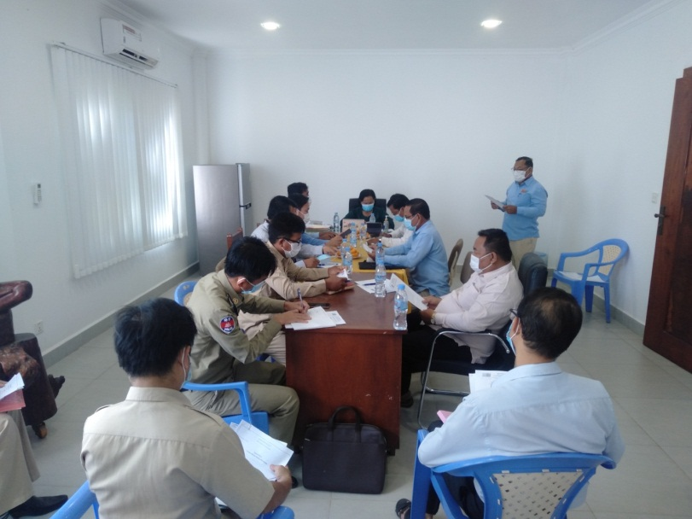

Technical working group meeting with DAC NGO networking meeting
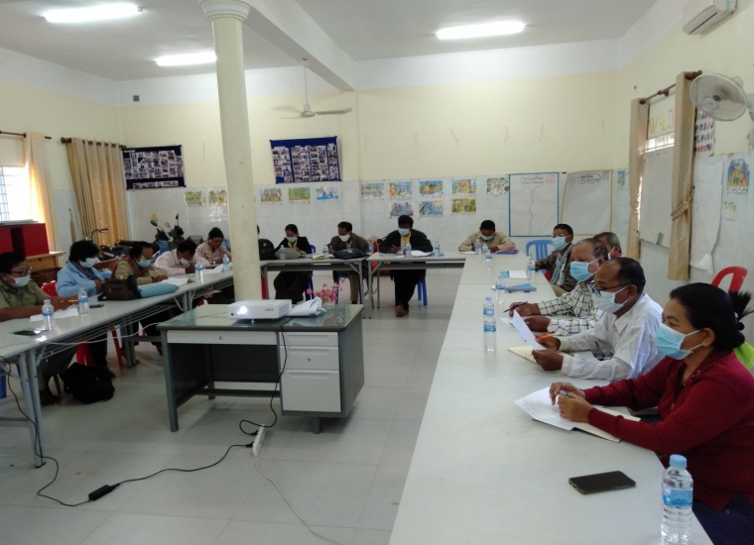
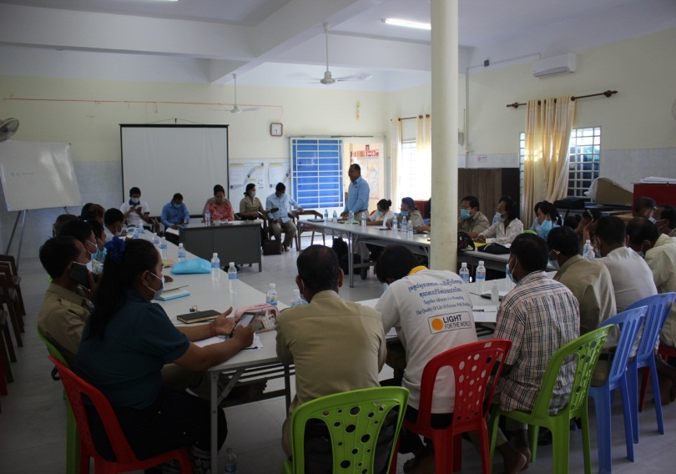

Formation commune budget was facilitated by DAC ​​​ Organized CDR Quarterly meeting
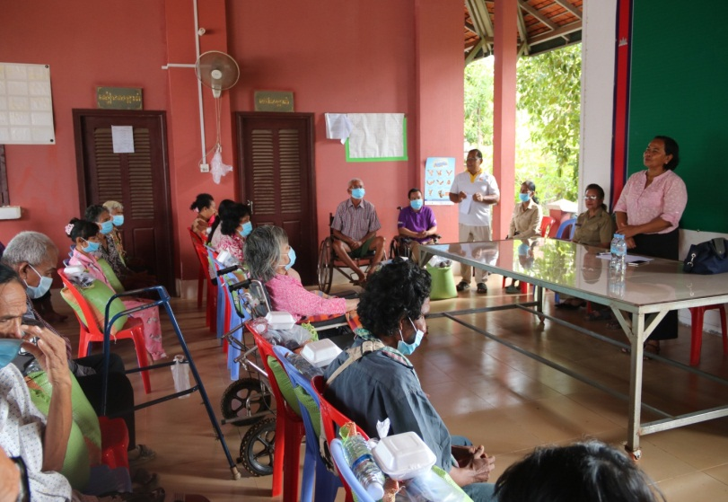
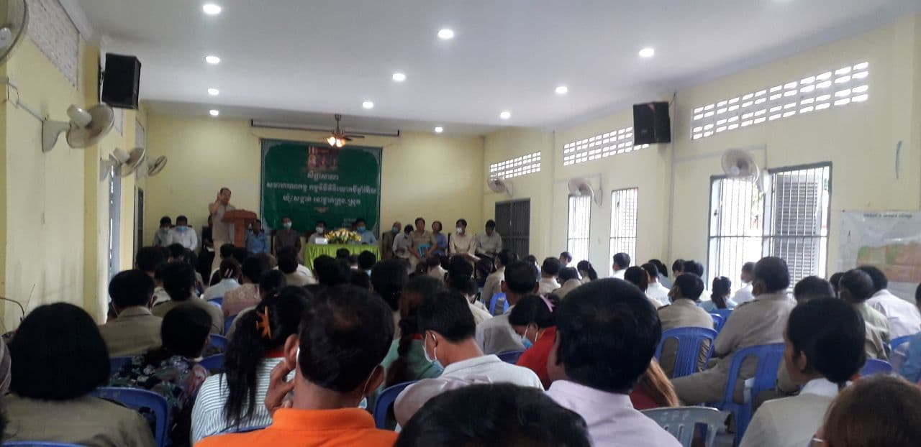

Visiting people with disabilities by DAC Districtg Integration workshop
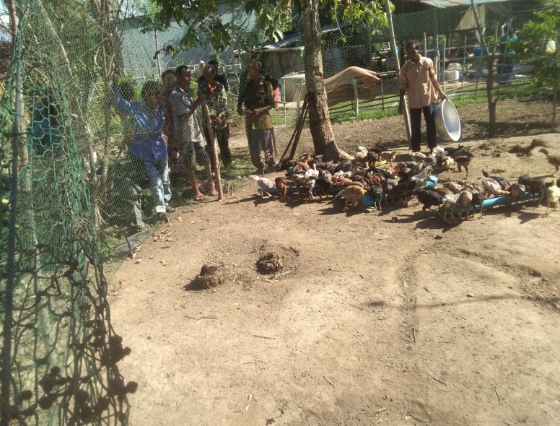
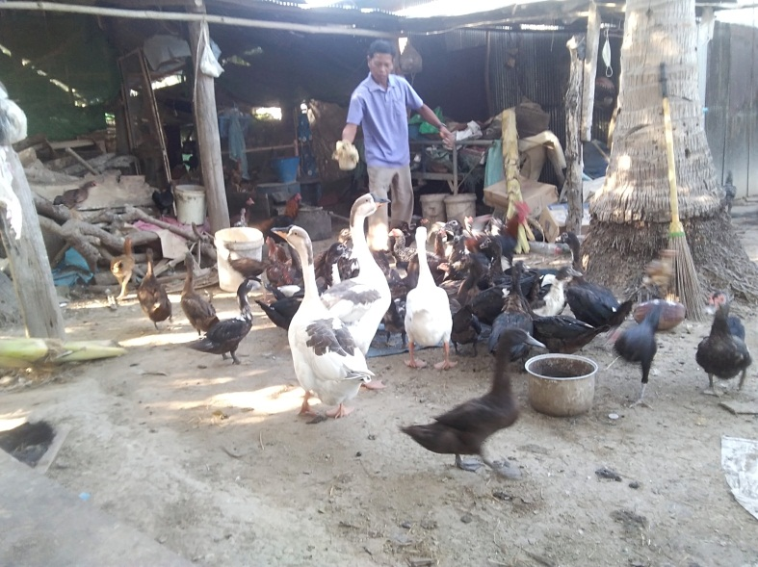

Model farmer 1 Model farmer 2

Project information
Project Name | Advocacy and communication for change (ACFC)
Project Number | 0349-1 of 1- L- KHM
Project Goal | To increase capacity of rural people with disabilities in communication and advocacy in order to empower them to voice their concerns and claim their rights.
Project Objective | 1:Rural persons with disability have improved capacity on communication and advocacy and advocate for their rights  2:Strengthen function and capacity existing structure of CDR/VDR to be effectively supporting persons with disability and local authority in addressing issues of PwD  3: Local authorities and other relevant stakeholders have greater understanding about the issues faced by persons with disabilities and make their project/service more inclusive of PwDs  4: Greater collaboration with the Disability Action Council (DAC) and the Persons With Disability Foundation (PWDF)  5: To documentation the project learning and best practice including developing relevant implementation guideline
Target areas | (255) villages, (21) Communes, (7) districts, Pursat province

Reporting Period | Jan -Dec‘2020 | Approved Budget: | $ 20,000
Project Country / Province | Cambodia, Pursat Province | Project Sector | Disability Inclusion
Expenditure for Jan Dec’2020 | $22786.31 | Expenditure (cumulative) | $22786.31

Note: Please attach any other relevant documents, i.e. key workshop reports, statistical summaries, etc... That you think would be informative / useful

1. Activity Level reporting – ‘What did we do?”

*ACTIVITY REPORTING: Please group all activities under agreed outcome/objective. For any activities or achievements that are not listed under objective, please report at the other achievements at the end of below table (Ex. Staff recruitment, any other workshop, training, etc).
This section should describe what activities had been planned and what was actually carried out. Please include figures e.g. numbers of workshops held, numbers of beneficiaries/participant etc... Please put NA if not applicable.
Activity  (description) | Planned target for this period | Actual for this period |  | Accumulative | Total Beneficiaries |  |  | Beneficiaries (split if possible) |  |  |  |  |  |  |  |  |  |  | Explain variation between planned and actual target  (Including the result description)
 |  |  |  |  |  |  |  | No. of women / girls |  |  | No. of women / girls with disabilities |  |  |  | No. of men / boys |  | No. of  men / boys with  disabilities
Objective 1: Rural persons with disability have improved capacity on communication and advocacy and advocate for their rights

1.1:Awareness raising to new target community about advocacy, disability and relevant law | - 15 trainings in 30 villages will provide at village level (1 to 2 villages in one trainings)  - The 300 PwDs including VDRs, improved knowledge advocacy, disability and relevant law |  | 2 Trainings | 2 Trainings | 46 | 2 |  |  | 9 |  |  |  |  |  | 10 |  | 27 |  | Awareness-raising on advocacy, disability and relevant law were organized to VDR, PWD ,village chiefs and community people, in 2 communes ( Kandieng and Bantay Dei commune, PWDs came from 6 villages  They gain knowledge on:  - Disability advocacy through the CIP process  - Increase awareness of communication and information flow on disability issues at the village level  - Demand for commune budget to support people with disabilities  - Disability inclusion  - Barriers to people with disabilities  - Attitudes toward disability  - Accessibility for people with disabilities  - Disability Causes / Disability Prevention  - Include people with disabilities  - Disability Definition Disability Types  - Communication and Listening Skills  Effective communication  - Disability in Cambodia (Poverty and Disability)
1.2:Support village disability representative to participate in relevant meeting at commune and district level | - Quarterly regular meeting at commune and district level  - Monthly regular meeting at commune  - The issues were addressed during the meeting with district and commune level and gain supports.  - Regular action points follow up |  | 22 meetings | 62 meetings | 70 |  |  |  | 0 |  |  |  |  |  |  |  | 70 |  | 70 VDRs were supported and invited to participate in CC meeting, they are from 21 communes, 32 villages  As always, VDRs are invited to attend the commune council mandate meetings and they are coordinated by the CDR and raise issues to address in the meeting. Generally, the VDR is not confident in its expression because they have never attended any meetings; however, we have CDR as commune council to help VDR .during the meeting, the commune council welcomed VDR as the commune council learned about the partnership during launching workshop and partnership meeting.  • VDR does not attend regular meetings unless there are major issues that need to be addressed; most of issues have been raised by the CDR to address, as the CDR is already as commune council  Issues raised:  Food shortage,  Shelter, toilet with ramp, Occupation, Referral patients (PWDs) to access health centre and Hospital, Clean water and PWD does not have a birth certificate, Wheelchair,  Equity Card ,ID poor, Capital for small business  Agricultural training  Some issues were solved.
1.3: Regular support / mentoring from DDSP with CC, CDRs and VDR. | - DDSP staff meeting with CC,  CDR & VDR frequently for supporting.  - CC & VDR participate in Meeting at district & provincial level.  - District & provincial authority include MoI allocate resources/budget for disability inclusion. |  | 21 meetings | 56  meetings | 56 | 34 |  |  | 0 |  |  |  |  |  | 22 |  | 0 |  | Mentoring.carried out through meeting by Phone, and face to face and some mentoring including find scholarship ,  formation of money box,  Formation of PWD association,  Village planning, identify the priorities needs for integrate them into CIP , the formation of PWD model farmers .  - The way to developing monthly work plan and report writing  - Structure of working  - Develop request and find supporters  –ToR  - updating PWD statistic,  - Flowing information from village level to commune and district level,  -Raised issue for finding solution in commune meeting  - CDR received good comments and feedback for improving next activities  -The Problem and solution
Objective 2: Strengthen function and capacity existing structure of CDR/VDR to be effectively supporting persons with disability and local authority in addressing issues of PwD

2.1:Refresher training to CDR and Commune council on disability inclusion, planning development, and advocacy | - 01 training sessions will be provided  - 20 CCs, and 20 CDRs improve knowledge of advocacy, disability and relevant law (Improved knowledge)  - Will improve the functioning of existing committee who are closely involved with project implementation | 1 training |  | 1 training | 21 |  |  | 13 |  |  |  | 0 |  |  | 8 |  | 0 |  | Refresher training was provided to CDR and CCs, they acquired knowledge on :  CIP process, proposal writing and requests , identifying Problem, Developing action plan , budget plan ,raised issues for finding solution in in meetings, conducted the Village meeting with PWDs groups to identify issues,  Facilitate VDR to participate in commune, district meeting, forum and other development activities,  Have ability to communicate and submit requests, flowing the information from Village to commune, district and provincial level.
2.2:Strengthening the existing structure of CDR or VDR | - Restructure VDR who are not active and select the new ones.  - At least 60% of CDR, VDR and village chiefs have increased their ability and Clear role and responsibility in working with PWD groups. | 1 Commune/  12 villages |  | 5  Communes/62  villages | 62 |  |  | 0 |  |  |  | 20 |  |  | 0 |  | 42 |  | Collaborated with CDR to update VDR and strengthen their capacity , they are:  1-Trapeng Chung:20 VDR  2-Svay At : 5 VDR  3-Bantay Day :12 VDR  4-Roleap :13 VDR  5-Sam Rong : 12 VDR  In order VDRs have the capacity to carry out their work, they were mentored by DDSP staff such as Providing immediate information ,flowing information about PWDs’ issues, TOR,  , developed request and raise issues for finding solution in CC meeting, and updating PWD statistic (Find the attached file)
2.3:CDR conduct community visit | - Community visit of all target villages will be conducted (3 visits/per commune/month)  - The needs of PWDs and Issues will be identified and address with relevant stakeholders  - PWD statistic in each village developed for VDR in working with PWD group.  - No. of Village mapping developed and identify PWD's house and issues are collected, take action through lobbying local authorities  - At least 50% of issues will be addressed (approx. ## case) | 2 Communes  2 CDRs  21 visits  11 village |  | 40 Communes  40 CDRs  191 visits  105 villages | 203 |  |  | 0 |  |  |  | 103 |  |  | 0 |  | 100 |  | Facilitated CDR to conduct PWDs visit in total 40 Communes  191 visits ,105 villages , the result as bellow :  1-Disabilities Issues:  203 people with disabilities raised concerns about food shortages, poor ID cards, chronic diseases without money for treatment,  lack of shelter, wheelchairs,  Lack of capital for small business,  Sanitation materials, Homeless  Lack of toilets  2-Solutions with stakeholders  MEW organization  Commune level  District level  DDSP organization  Commune / Village  Government Working Group  Ministry of Disability Fund  Provincial Governor  Red Cross  Department of Planning  Social Affairs  Women's Association Network  The monks at the pagoda and charity team  3-The result:  Budget supported 2,272,075 Riels  1420 kg of rice  7 shelters  14 toilets  5 ID poor  3 family equity card  1 Wheelchair  Barber Tools and Other materials
2.4:Assist and coach CDR , VDR on proposal development and referred to local authorities and relevant stake holders to support the needs of PWDs which related to food shortage, house repairing, referral to health centre and addressing other issues | - A number of trainings/coaching /mentoring held for capacity building of CDR, VDR.  - At least 60% proposal of supported PWDs and received fund from local authorities, NGOs by 2020  - At least 60% of PWDs who  - have issues are identified and addressed their issues including food shortage, house repairing, referral to health center, birth certificate, ID poor and other issues | 9 requests |  | 30  requests | 135 |  |  | 0 |  |  |  | 66 |  |  |  |  | 69 |  | Facilitated CDR to developed 28 requests :  - 4 requests for Shelter  - 14 requests for food support  - 2 request for small business.  - 9 Requests for budget in Pagoda (money box)  - 1 Request for Toilet for PWD Addressing by stakeholders  - Provincial governor,  - District , PoSVY,  - Government work group  - DDSP ,  - Commune  - Relevant stakeholders  - MEW organization  - Ministry of Disability Fund  - The result:  465 kg of rice are supported to PWDs,  Budget supported 550,000 Riels, with 500 $.  4 shelters are  13 Toilets, and also supported other material such as Fish sauce, Soap, Kitchen materials ,Haircut material  (For detail please find the attached file)
2.5: Support local authorities to include persons with disability in planning meeting, decision meeting at the new villages (E.g. village planning meeting, CIP process etc ). | - PwDs will be supported/involved in village planning meeting/decision making ( 228 villages – coordination of DDSP & CDR)  - Issues/concerns of PWDs have identified and raised during planning meeting and continue to address to CCs and relevant stakeholders.  - The number of issues  - prioritized by the PWDs during in the CIP process | Achieved |  | 204 villages/255  villages | 3244 |  |  | 753 |  |  |  | 566 |  |  | 611 |  | 855 |  | 1:At village level:  Facilitated CDR and VDR to organize village meeting with PWD groups also, DDSP has joined with them. The issues have been listed in charts in order to incorporate them into the CIP.  The priority needs as bellow:  - Food shortage  - Shelters  -Capital for small business  - Health service  - Toilet with Ramp  - Wheelchair  - Emergency support  - Health education  -Sanitation materials  - Entrance and exit with accessible at commune hall and toilets.  - Vocational skills  - Assistive devices  -water filters  -Water jars  -Studying materials for PWD's children  - Scholarship for PWDs ’children  2: At a commune level:  • DDSP has assisted and trained 21 CDR in 21 communes in order to make them able to participate in the local planning processes. There are 21 CDR who participated and incorporated all the priority needs in the CIP.
 | District integration workshop  in 7 districts | 7 meetings  (7 districts) |  | 7 meetings  (7 districts) | 747 |  |  | 203 |  |  |  | 3 |  |  | 531 |  | 10 |  | 3:At a district level :  • DDSP staffs participated in district integration workshop in total 7 districts and has assisted and supported CDR and VDR to enable them to participate in district integration workshop, there are 21 CDR and13 VDR who participated and find the supporter, In this step, NGOs and government departments selected the projects in order to Carry out in 2021 so that they can be implemented.  (For detail please find the statistic  in attached file)
 | 3 year planning meeting with CCs | 1 meeting |  | 1 meeting | 27 |  |  | 9 |  |  |  | 1 |  |  | 12 |  | 5 |  | Coordinated CDR in  Prey Nhy commune to attend a 3-year planning meeting and allocated 4,350,000 riels for supporting PWDs
2.6: CDR and VDRs participate in monthly commune meeting and quarterly district meeting. | - Quarterly regular meeting at District level.  - Regular monthly meeting at Commune level.  - The issues were addressed during the meeting with district and commune level and gain supports.  - Regular action points follow up | 21 Communes/  42 meetings |  | 62  Communes/186  meetings | 1682 |  |  | 392 |  |  |  | 7 |  |  | 1062 |  | 92 |  | 1: CDRs and VDR participated in monthly commune meeting:  Facilitated CDR and VDR to participate in commune mandate meeting ,there were commune councils Health centre staff, village chiefs and other relevant stakeholders to discus and find solution about PWDs’ issues  2:-Issues raised: total :10 cases:  - Lack of food  - Shelter  - Toilet  - Occupation  - Referral patients (PWDs) to access health centre and Hospital, Clean water  - Birth certificate  - Wheelchair  - ID poor  - Capital for small business  - Agricultural training and vegetable seeds  3:Solution for issues::  Some issues were solved :  - For referral to health center,  commune councils and health centre has allocated funds to support PWDs  -Food supported, during Covid-19 by DDSP with some materials and by the government.  -Vegetable seeds supported by Department of Agriculture and use commune budget.  - Toilets supported by EMW Org  and with other materials.
Objective 3: Local authorities and other relevant stakeholders have greater understanding about the issues faced by persons with disabilities and make their project/service more inclusive of PwDs

3.1:Translate the “Communication matter” to Khmer version (phase 2) and Disseminate the research finding results to relevant authority through meeting/training/workshop | - The research report will be translated to Khmer version and disseminate among stakeholders  - 100 copies of report printed  - 65% of civil society, all stakeholders and PWDs will understand the issues , challenges and more understanding on current situation of PWD  - The relevant stakeholders will make program/services more inclusive | Draft  But not finally |  | 4 meetings | 79 |  | 33 |  |  | 2 |  |  | 44 |  |  | 0 |  | “Communication matter” was Translated to Khmer version (phase 2) and disseminate among stakeholders through NGO network meeting and CDR Quarterly meeting
3.2: Conduct provincial public forum on disability inclusion. | - Two Provincial forum will be  - organized  - Attended by PWDs , CDRs  - ,VDRs , DAC, and other relevant stakeholders = 99 participants  - The disability issues will be addressed and responded during the forum  - PWDs’ issues were raised through dialogues in the forum.  - Number of cases/issues will be solved/ clarified. | N/A |  |  |  |  |  |  |  |  |  |  |  |  |  |  |  | The draft of the provincial public forum has been prepared and consulted with the DAC and the provincial relevant stakeholders department, but due to Covid-19 , this activity was delayed from day to day and it is not possible
3.3:Follow up the issues raised by PWDs during village planning , issues raised in provincial public forum and commune budget package that formed for addressing PWD’s issues | - 15 people with disabilities were interviewed  - 10 VDR were interviewed  - All target commune monitored  - At least 60% requests of VDR are supported and received fund from commune councils. | 227 follow ups/  In 21 communes |  | 227 follow ups/ In 21 communes | 1047 |  | 191 |  |  | 321 |  |  | 134 |  |  | 401 |  | Institutions support through inclusion of disability needs in CIP:  Provincial youth group  Charities  Department of Planning Department of Agriculture  Department of Social Affairs Red Cross  Women's Affair  The Monk in Pagoda  RFCD, EPDO, ANKO BK, LWD, API, ADRA F2D, ICRC, HEKS, ASPIR COCD, RACHA Mlup Russey,  Sre Khmer,DDSP  The resalt Achieved:  Shelters  Toilets  Food supported  Animal seed  Equity Card  Agricultural Training  Delivery service  Health promotion  Mix Vegetable seed  Scholarship  Capital for small business  (For detail please find t statistic in the attached file)
3.4:Conduct quarterly NGOs network meeting | - NGO network meetings will be conducted and at least 4 meetings organized  - Disability issues are addressed and responded to during network meetings and potential collaborations identified (across sectors e.g health, education, agriculture)  - Regular action points follow up | 1 meeting |  | 2 meetings | 58 |  | 9 |  |  | 2 |  |  | 30 |  |  | 0 |  | NGO network meetings was held at DDSP's vocational training center; there were local organizations, POsVY,  The meeting focused on:  Sharing the information Matter to participants,  Collecting ideas/  recommendations for improving the quality of lives of PWD, greater collaboration among participants, Greater understanding of the communication and information flow about disability issues and shared importance information to each other ( government policies through CCC information)
3.5:Conduct provincial meeting to mobilize resource with Commune Chief, CDR, “CCWC”, DoSVY , District governors) | - One meeting will be organized which facilitated by provincial DAC (deputy-provincial governor)  - Number of agreements made between CCs, CDR, DDSP and District governors  - 60% of the local leaders (commune councils) will create commune budget line supporting PWDs  - 80% of CCs make their service/programs more inclusive | Achieved |  | 1 meeting | 39 |  | 16 |  |  | 1 |  |  | 22 |  |  | 0 |  | Done in Q3 ‘2020  Organized coordination meeting on funding allocation was undertaken with key stakeholders including DAC, PoSVY, District governor, Commune chiefs, CDR, and other relevant stakeholders  The result:  the commune budget package for supporting PWDs were formed in  21 target communes (100% of target communes, total 10.200.000 Riels, now the commune have specific budget line which is never have before.  (For detail please find the minute in attached file)
3.7: Increase Disability model farmer’s practices and support them to link with gov’t and NGOs initiative. | - At least New 7 model farmers were formed  - No. of CDR’ proposals supported by CCs, utilizing funds from communes budget line  - No. of CDR’ proposals supported by relevant stakeholders (NGOs, PDA)  - All the existing Model farmers are strengthened | 1commune/1 village |  | 5 communes/14 villages | 21 model farmers |  | 0 |  |  | 7 |  |  | 0 |  |  | 14 |  | 21 PWDs model farmers were formed in 5 communes 14 villages,their activities include:  Raising chickens and growing vegetables, out of 21 model farmers there are 2 model farmers who have good practice which can be demonstrated to other farmers,  But they need to be trained in coordination and presentation skills (Please find the attached file)
 | - Organizing cross visit for PWD group to learn about chicken raising and vegetable growing for model farmers | 1 cross visit |  | 2 cross visits | 37 |  | 5 |  |  | 7 |  |  | 10 |  |  | 15 |  | DDSP supported PWDs groups in Snam Presh , Metuek and Boeng Kna commune ,total 4 villages, to attend cross visit which conducted by DDSP collaborated with CDR, there were37 participants including 12 women ,they learnt about successful experience from model farmers such as family chicken raising and vegetable growing from Model farmers at Roung village and Sakor village.
3.8:Advocate/lobby the Provincial department of agriculture and community trainers to support model farmers and PWDs Groups | - Volunteer trainers from the Department of Agriculture and the community trainers will provide livestock and vegetable skills training to disabled farmers  - 5 courses of refresher Training on rising chicken and vegetable growing. in 10 villages to 60 PWDs including 15 women  - 50% of PWDs received vegetable seeds from commune councils for their home gardens,  - Number of exposure visits to internal and external target areas.  - 50 % of participants acquired new knowledge and 30% put what they have learnt from training into practice, the knowledge will spread in the community through sharing successful lesson learn | Achieved |  | 5 Trainings | 59 |  | 8 |  |  | 15 |  |  | 12 |  |  | 24 |  | PWDs groups have opportunity to participate in training ,they acquired new knowledge and out of 59 PWDs, there were 25 PWD do what they have learnt into practice
3.9:Providing on job training to 5 model farmers on presentation skills for sharing their sucessful experience to PWDs famers groups | - 7 model farmers were coached and provide feedback for improving presentation skills  - Identify successful farmers to demonstrate. through meeting or home visit  - At least five model farmers shared their experiences to PWD groups | Achieved |  | 1 training | 9 |  | 1 |  |  | 0 |  |  | 2 |  |  | 6 |  | Six model farmers are trained in presentation skills  Such as facilitation skills  Communication, Agenda preparation, Presentation method, Process of chicken raising and vegetables growing and during the cross they shared experience on Chicken raising and vegetable growing to PWD group .
3.10: Support and refer PwDs for assistive device, emergency response and legal support. | - 30 Case (individual or family) have been supported or referred to relevant services | 3 Cases |  | 15  Cases | 41 |  | 0 |  |  | 14 |  |  | 0 |  |  | 27 |  | During the report period ,  Most 41 vulnerable PWDs were supported; each of them have got 25 kg of rice and repairing shelters and Referral for leg repairing  (6 PWDs)  ( Please find the attached file )
3.11: Advocate/lobby Health center to Conduct health care and hygiene awareness-raising to PWD groups (Including provide disability awareness to Health Center- Using the Inclusion Game)  ​ | - Number of training session provided to HC  - Number of training awareness on health provided to community including PwDs by HC | 1 meeting |  | 6 Meetings | 275 |  | 57 |  |  | 39 |  |  | 82 |  |  | 97 |  | DDSP collaborated with CDR, Health center and police man, to Conduct health care and hygiene awareness-raising to PWD groups in:  1-Pray Nhi commune  2-Tropeng chung commune  3-Veal Veng commune  4-Boeng Khar commune  5-Kandieng commune  Activities 3.11 and 3.12 were implemented together and allocating time for facilitator from Health center and Police man  (Please find the minute in the attached file)
3.12: Advocate/lobby and Collaboration with the Police man to mainstream awareness raising on domestic violence to PWD and community (including awareness raising on disability to policeman etc) | - Number of awareness raising  - Number of case resolve | 1 meeting |  | 6 Meetings | 275 |  | 57 |  |  | 39 |  |  | 82 |  |  | 97 |  | Activities 3.11 and 3.12 were implemented together and allocating time for facilitator from Health center and Police man
3.13: Advocate/lobby school teachers, Department of Education, CCWC, to find scholarship for poor children with disabilities | - Number of Children getting support! | 2 meetings |  | 21  meetings | 38 |  | 11 |  |  | 6 |  |  | 8 |  |  | 13 |  | ​38 children were supported scholarship , they are in Boeng Knar , Thnot Chum commune ,Kandieng, , Sam Rong. Santre, Boeng Botkandol,Bantay Dei, and Tolo commune.  (for detail please find the list of children who have got Scholarship in the attached file)
Objective 4: Greater collaboration with the Disability Action Council (DAC) and the Persons With Disability Foundation (PWDF)

4.1: Conducting internal project M&E activities | - DAC & PWDF, CDR, PoSVY  - Join M & E activities with DDSP team.  - 3 Visits will be conducted | 5 times |  | 5 times | 68 |  | 14 |  |  | 10 |  |  |  | 25 |  | 19 |  |  |  | Collaborated with DAC. PoSvy, DDSP, CC, VDR, CDR, District governor, Visiting people with disabilities, DAC encourages people with disabilities to practice hygiene, Struggle to live. Disability statistics must be collected and be aware of the needs that need to be supported
4.2: Technical working group meeting | - There is representative of DAC & PWDF, PosVY, and Relevant provincial department in technical working group.  - At least 4 meetings organized for technical working with DAC and PWDF | 1 meeting |  | 1 meeting | 17 |  | 3 |  |  | 0 |  |  |  | 14 |  | 0 |  |  |  | Meeting with the DAC as a consultative the process of implementing a number of activities, such as :  1-Organizing provincial forum  2- Consultative workshop  3- Training on basic advocacy.  4-Meeting with Relevant stakeholders ,on the using commune budget for supporting PWDs, the participants are  DAC, District governor,  PoSVY, department of  planning , Red cross, department of woman affair, Education, Police officer, and other government agencies  This is to set the date and give the opportunity to the DAC to participate in the events.
Objective 5: To documentation the project learning and best practice including developing relevant implementation guideline

5.1: Desk review and content development | - All relevant documents have been reviewed and consolidate.  - The practical contents for project documentation, guideline will be developed | N/A |  |  |  |  |  |  |  |  |  |  |  |  |  |  |  |  |  | Need more time to carry out
5.2: Drafting and finalize the relevant project implementation guideline including consultation meeting. | - Project implementation guideline will be developed and sharing | Have some guideline |  |  |  |  |  |  |  |  |  |  |  |  |  |  |  |  |  | Some activities of the project implementation are developed guideline such as the formation of PWD association,CIP Process  ( village planning with  PWDs' groups, Request of PWD, TOR of CDR, and VDR  For detail please find the attached files
5.3:Learning reflection workshop | - Learning and reflection workshop conducted with key relevant stakeholders. | N/A |  |  |  |  |  |  |  |  |  |  |  |  |  |  |  |  |  | We have already planned  but due to Covit-19 , so it is not implement
Other Achievement
Conducted field visit with Nil , visit water cart, and product cart |  | 1 visit |  | 1 visit | 5 |  | 0 |  |  | 1 |  |  |  | 3 |  | 1 |  |  |  | Facilitated field visit to see water cart and Product cart and then visit training center and Srey Mom's Motorbike also Discussed about questionnaire for Agri-Lab
Project introduction to CDR (Q1) |  | 1 meeting |  | 1 meeting | 21 |  | 14 |  |  | 0 |  |  |  | 7 |  | 0 |  |  |  | 21 CDRs were invited to participate in project introduction meeting  from the meeting they increased they understanding of the project activities and build strong good collaboration between DDSP and CDR, commune councils and relevant stakeholders and define roles and responsibilities of commune councils and CDR and also they  Agreed on the project implementation.
Organized CDR quarterly meeting |  | 1 meeting |  | 2 meetings | 42 |  | 28 |  |  | 0 |  |  |  | 14 |  | 0 |  |  |  | Through quarterly meeting CDRs reported quarterly results and plan for the next quarter,  shared successful lesson learnt, discussion on technical Working, good feedback and comments for improving the ability of CDRs  Reflection strong and weakness of CDRs and encourage them in project implementation with right direction  Built good collaboration among CDRs and good solidarity, shared good practice to each other’s.
Emergency support to Vulnerable PWDs  during Covid-19 | 119 PWDs , supported by CFA project | 1 time |  | 1 time | 119 |  | 0 |  |  | 65 |  |  |  | 0 |  | 54 |  |  |  | Emergency support to PWDs in Bakan , Kandien and Krakor District in totally 119 PWDs
Emergency support to CDR during Covid-19 | 49 CDRs supported by CFA project | 1 time |  | 1 time | 49 |  | 26 |  |  | 0 |  |  |  | 23 |  | 0 |  |  |  | Emergency support to CDR in total 49 Communes
Emergency support to Vulnerable PWDs  during Covid-19 | 139 PWD supported by  Sir Bobby Charlton | 1 time |  | 1 time | 139 |  | 0 |  |  | 32 |  |  |  | 0 |  | 107 |  |  |  | VV : 100/13  KV :20/11  Talo :15/8  SamRong: 4/0  Total:139/32
Emergency support to CCs during Covid-19 | 5 CCs supported by  Sir Bobby Charlton | 1 time |  | 1 time | 5 |  | 1 |  |  | 0 |  |  |  | 4 |  | 0 |  |  |  | Veal Venh district in 5 communes
Mainstreaming Agti-Lab training activities |  | 1 meeting |  | 1 meeting | 21 |  | 14 |  |  | 0 |  |  |  | 7 |  | 0 |  |  |  | Mainstreaming Agti-Lab training activities to CDR in 21 communes they like innovation of equipment for PWD, but have to adjust the quality and use an auxiliary motor
2. Strength and Challenges
*** Please give a short overview of the main strengths, and challenges of the following points:

- The project itself (successes, problems encountered, solutions found) | SUCCESS: Project profile raising, Representation, Communication and Capacity building:  - In all major project activities, the DAC plays an important role in facilitating, such as: technical groups meeting, the formation commune budget to support PWD groups in each commune, visiting people with disabilities, the organizing the Public forum at provincial level, workshop, and meeting etc.  - Provide knowledge and educated on Covid-19 to communities and people with disabilities in collaboration with stakeholders, including health centers, police and authorities, especially provided emergency assistance during Covid-19 infection.  - At the beginning of project implementation, all CDR , CCs and relevant stakeholders were introduced about the project activities; this introduction helps them to be more competent and to reinforce the ability of partners for cooperation in the right direction that so far have actively participated in the project.  - The existing structure of CDRs was strengthened through coaching, orientation the necessary capacity building to implement the projects. So far, the structure and its functioning have been greatly supporting the project implantation  - Strong staff’s commitment and good collaboration with local authority from commune level, district level and provincial level.  Problems encountered:  - Cambodia also affected by Covid-19, so some activities are postponed Such as forum, workshops, training, and cross visit for CDR etc...  - the flooding disaster situation​ in Pursat province affected to project implementation, disaster are keep continues affected to PWDs’ livelihood until now .  - With many target communes, project staff was extremely busy with coordinate the whole project implementation and at same time the project staff has not enough time to cover all activities of the project.  - Do not have enough time for developing documentation on ​Project implementation guideline and sharing  - Due to the low level of knowledge of people with disabilities, the project is difficult to select people with disabilities in the village to work effectively, and some of them are changed.  Solution :  - Due to Covid-19, and flooding disaster some activities are postponed and flexible by changing project activities to replace by emergency food support.  - DDSP build capacity building to CDRs through training, coaching, orientation, mentoring monitoring and communicate by phone, Telegram, or face to face, or meeting with feedback so that they acquired Knowledge and are able to work by themselves  - Rotation in participating in commune meeting and other activities by working with partners and facilitate CDRs and VDR to participate in meeting.  - Strengthening the existing VDR and selected VDR who are not active with build the capacities
- Your organisation’s performance (staff, PME systems, work load, etc.) | Strength:  - DDSP have many year working experiences on Disability and community development which is great to contribute to the project.  - DDSP has good partnership and networking with all relevant stakeholders in disability selector and mainstream sector.  - Clear organization policies, procedure,  - DDSP are strong in Disability Inclusion work and have good connection with network both NGO and government.  - Organization management structure.  - Good Financial Management System, policies are in place.  Challenges:  - Lack of human resource for doing fundraising and communication.  - Project monitoring and evaluation is still a limitation due to time and human/financial resource constraints.  - The existing donors are short term support. Some of donor ware pulling out. This was affect to some staff as well.
3. Reporting against M&E plan (outcome / objective level)
"What difference is the project making?”
Name / Type | Progress against M&E Plan
Objective 1: Rural persons with disability have improved capacity on communication and advocacy and advocate for their rights | - Awareness-raising on advocacy, disability and relevant law were organized to VDR, PWD ,village chiefs and community people, in 2 communes ( Kandieng and Bantay Dei commune, PWDs came from 6 villages , they acquired knowledge and reduced discrimination in communities.  - During the project​​ implementation, project staff coordinates VDRs, attending commune mandate  - meetings, the issues are dealt with food shortage, lack of shelter ,health service ,Chronic illness of PWD ,Lack of budget for disease , equality card and Other materials . All issues are addressed through the Provincial Department of Social Affairs, the use of commune budget, community mobilization for shelter construction, supported from local NGOs and government. Through the supporting they are so happy and have great confidence and have high interested with the project implementation.  - Mentoring.carried out through meeting by Phone, and face to face and some mentoring including village planning, , the way to developing monthly work plan, report writing ,structure of working, the way to develop request and find supporters ,ToR, updating PWD statistic, flowing information from village level to commune and district level, raised issue for finding solution in commune meeting ,CDR received good comments and feedback for improving next activities so that they have ability to work with effectiveness.
Objective 2: Strengthen function and capacity existing structure of CDR/VDR to be effectively supporting persons with disability and local authority in addressing issues of PwD | - Refresher training was provided to CDR and CCs, they acquired knowledge and improve knowledge of advocacy, disability and have ability to work with relevant stakeholders.  - Restructure VDR who are not active and select the new ones, this activity is implemented. VDR played an important role in providing information on issues of PWDs' groups as they lived directly with the disabled in the village  - Facilitated CDR to developed 28 requests that related to Shelter repairing, food support, small business, Toilet for PWD these requests are Addressed by stakeholders including ,Provincial governor, District level, PoSVY, Government work group , DDSP , Commune councils, Relevant stakeholders, MEW organization ,Ministry of Disability Fund. These are CDR’s capability which is facilitated by DDSP staff.  - CDR in all target communes visited people with disabilities in the villages and identified problems for addressing with relevant stakeholders, The main problem is emergency support for people with disabilities is addressed by using the commune budget, Provincial Red Cross, PoSVY, local authorities, Provincial Departments, Local charities, provincial governor, DDSP, most of intervention by providing information and requests by CDR, which receives more information from VDR in each village.  - 21 existing CDRs and VDRs are oriented on project activities and also stated about role and responsibility, planning, report and minute writing, flowing information of PWD from village level to commune and district level, raising the issues of PWD for finding solution at commune meeting, district meeting and provincial meeting especially find supporters for supporting PWD They know what to do and how to do thing.  - People with disabilities often faced with problems that need to be addressed immediately Such as lack of food, shelter, health services issues, these issues were addressed through direct visits to persons with disabilities and developed requests for submission to commune chiefs, Red cross, PoSVY, individual Charity and others, the requests were developed and PWDs were provided food support and they reduce food shortage during Covid-19 happened.  - Commune councils conducted regular monthly meeting and in the meeting there were CDRs participate and at the same time DDSP also Coordinated CDR and VDR to raise issues​​ for finding solutions.
Objective 3: Local authorities and other relevant stakeholders have greater understanding about the issues faced by persons with disabilities and make their project/service more inclusive of PwDs | - Communication matter” was Translated to Khmer version (phase 2) and disseminate among stakeholders through NGO network meeting and CDR Quarterly meeting , They are interested with report finding and requesting documents for their using  - Follow up the issues raised by PWDs during village planning ,the institutions support through inclusion of disability needs in CIP included:  Provincial youth group ,Charities, Department of Planning, Department of Agriculture, Department of Social Affairs , Red Cross ,Women's Affair .The Monk in Pagoda ,RFCD, EPDO, ANKO BK, LWD, API, ADRA F2D, ICRC, HEKS, ASPIR COCD, RACHA Mlup Russey, Sre Khmer,DDSP the result as bellow  Shelters ,Toilets , Food supported ,Animal seed ,Equity Card ,Agricultural Training ,Delivery service Health promotion ,Mix Vegetable seed, Scholarship ,Capital for small business etc....  - Health center and police were very supportive in education of health care, hygiene, Covid-19 and mainstream awareness rising on domestic violence to PWD groups and Community as a result, we Achieved five communes Trorpeng Chung , Prey Nhi ,Boeng Kna , Promoy and Kandieng Commune  - With high attention to people with disabilities, all target communes have formed the commune budget package to support people with disabilities ,this case was approved by the DAC, PoSVY, District governor, commune chiefs, and CDR.  - The education sector also pays close attention to children with disabilities and provides scholarships to poor and disabled students.
Objective 4: Greater collaboration with the Disability Action Council (DAC) and the Persons With Disability Foundation (PWDF) | - Collaborated with DAC. PoSvy, DDSP, CC, VDR, CDR, District governor, Visiting people with disabilities, DAC encourages people with disabilities to practice hygiene, Struggle to live. Disability statistics must be collected and be aware of the needs that need to be supported .Therefore, the DAC and relevant stakeholders have strong supported and good cooperated with great care for people with disabilities.  - All departments are DAC , PoSVY , provincial red cross, Education department,​ health center, Department of Women affaire, District governors, and some other relevant stake holders of government are involved in project activities, such as discussions on how to organize a public forum, workshop , meetings and also engage in the main speakers, and Answered all the questions of PWDs.
Objective 5: To documentation the project learning and best practice including developing relevant implementation guideline | - On-going process, the result achieved such as the process of CIP, village planning, forum, TOR of CDR VDR, bylaws of association etc....  - Other activities will be documentation the project learning and best practice including developing relevant implementation guideline
Note:
COMMUNICATION - Please add at least one story and one photo that relates to one of your Objectives above. This section is to record the changes g to communities, stakeholders and beneficiaries that have taken place as a result of the project activities. Please refer to Project M & E plan.
- Can LFTW use this story / photo in their communications (tick: yes □ or No □ )

4. Cooperation and performance
- Describe your cooperation with other organizations during the project period. Also, describe your cooperation with local authorities/ government institutions. Mention successes, problems and opportunities for cooperation. |  | Provincial level :  - In 2020, although the project has just begun and there are issues with Covid-19, and flooding situation but the collaboration between DDSP and relevant stakeholder and DAC has remained good communication because they have been working as partnership for many years.  All major activities of the project can be communicated directly or via telephone​ DAC has paid attention to PWDs and has actively supported the project activities.  - Commune and District Level  All target district governors were very supportive and participants in the meeting, workshop, consultative meeting required by the project.  - Through the established structure of commune disability representative (CDRs)- all of them were coming from commune council so the cooperation was also built with all commune council members. There were regular monthly meeting and disability became one of their agenda.  - NGO level:  Due to covid-19, and flooding situation ,NGO meeting was postponed for a while ,in 2020 NGO network meeting were organized in Q3 and Q4
- Do you have any specific feedback from the community about the project? What are their views? Are they happy with the progress? Do they have any challenges or criticisms? Can we do anything better for them? |  | - Local authorities and beneficiaries are ​enjoy by supporting from DDSP and LFTW such as PWDs empowerment, participated in decision making, Emergency support, shelter repairing and some activities etc...  - In 2018, the project covers the whole province, but 2020 has reduced to only 21/49 communes, and CDRs who reduced suggested to DDSP, they needs more support from DDSP.  - During commune and district meeting there were some questions from relevant stakeholders, local authorities, village chiefs, CCs and PWDs about project supporting. They also suggested to DDSP to find out project support for PWDs as there were many issues for PWDs such as food support, shelter, sanitation materials, capital for small business, vocational training, toilet with ramp, referral to health center etc...
- Are there any other issues you would like to raise? |  | - Due to covid-19, some activities are postponed for a while such as forum , Workshop and meetings  - Project staff has resigned from the project, staff turns over.
- Communication
How has the collaboration been with LFTW – is there anything we can do to improve? | 1: Visibility & Communication:  - Collaborate with the police and CDR to educate people with disabilities and the community on domestic violence that causes disability , Social Security Education, the use of drug  This is a part of preventing of disability by using education picture.  - To improve the livelihoods of communities and people with disabilities ុំDDSP Collaborated with agricultural trainers to provide livestock raising skills and vegetable growing skills to communities and people with disabilities ​  - To ensure that PWDs and People in community are aware of Covid-19 , DDSP collaborated with Health center educated sanitation , covid-19 with prevention measure by using education picture to be used during emergency food support and stick in public places, commune hall, pagoda and health center .  2: Communication:  - Good cooperation between DDSP and LFTW, all issues and support needs are always discussed. So far, there are enough space for discussion and communication through email, phone, face to face and this is very useful.  - The process of report review was good as there were two way communications. Comments/ question, response/clarification and finalize.  3: Collaboration with LFTW:  - LFTW is working closely with DDSP to provide strong support to discuss about consultative on proposal writing and budget planning, project implementation, provided feedback on time in reporting, technical supported and project orientation for improving the project implementation.
- Do you have any suggestions to make the project more successful? | - Due to the mandate of local authorities and the changing of their management, the project must continue to build their capacity on disabilities sectors to the new relevant stakeholders.  - In order to improve the quality and sustainability , the project should continuous strengthening the capacity to the existing CCs, CDR and VDR on advocacy and communication skill, good relationship with local authorities at provincial level, district level, commune level ,NGOs and others relevant stakeholders.  - Number of project staff must be balanced with target area  - Consider transportation and communication service of CDR to work with PWDs group in the community ​( monthly allowance for transportation and communication service)
- Lesson learn

Main lesson learned | Lesson learn:  - Communicated and lobbying DAC to facilitate the importance project activities and Formation working structure from village level to provincial level  - Facilitated the formation commune budget package to support PWDs' s groups.  - Incorporated issues and needs of people with disabilities into the CIP process  - Educate knowledge about Covi-19 with prevention measures also provided emergency food to people with disabilities  - Communicated and lobbying schooling teacher to find scholarships for children with disabilities to attending school.  - Communicated and lobbying police man to educate communities and PWDs' group on social security ,domestic violence and the use of drug  - Communicated and lobbying Health center to educate about sanitation , Hygiene and Covi-19 with prevention measures.  - Communicated and lobbying agricultural trainer to provide chicken raising skill and vegetable skills to PWDS' groups.  - Facilitated the formation of PWD association and raised funds to support PWD association by submitting proposals to various institutions and have money box in pagodas.  - Planned to establish community schools with village agricultural trainers and model farmers to share chicken raising and vegetable growing techniques to people with disabilities.  - Strengthening the existing structure of CDR or VDR:  The existing disability structure were strengthened for communicating and addressing the issues of people with disability  - Support VDR to participate in relevant meeting:  Support village disability representative to participate in relevant meeting at commune and district level. They brought the issues to be resolved with the commune and stakeholders  - Regular support / mentoring from DDSP with CC, CDRs and VDR  Mentoring from DDSP with CDRs and VDR In order them have the capacity to carry out their work, such as Providing immediate information for supporting, developed request and raise issues for finding solution and supporting and other needs etc...  - Information flow from the local level :  DDSP closely collaborated with CDRs, VDR, CCs village chiefs joined with the PWDs groups to identify their needs for finding solution.  - CDR conduct community visit  Home visits to people with disabilities can be addressed emergency issues for persons with disabilities such as lack of food, emergency treatment by using the commune's budget and develop request to relevance stakeholders.  - Scope of works:  the project activities were covering 255/511 villages ,21 /49 communes, 7 districts  - Working Structuring:  Working with the existing CDR and VDR and CCs, it is helps the project in coordinating the information flow from the village to commune and district level  - Regular meeting, catch up and action:  During the report period DDSP facilitated and encouraged CDRs to identify PWDs’ issues for incorporation into the commune meeting and district meeting, as result, some issues were addressed such as food support and house repairing
Date: 5 Dec’ 2021
Prepared by
Project coordinator

Sam Sareth

